Table of Contents
Dating Subset Analyses……………...…………………………..………………………… p. 2
First Target (N = 208) Analyses……………...…………………….……………………… p. 15
Random Forests Moderation Simulations………………………………………………….. p. 17
Random Forests Analyses with State Self-Reports...……………………………………… p. 21
Nested Resampling Method Using Three Missing Data Imputation Approaches…………. p. 24
Ideal-Partner Preference Matching: Response Surface Analyses.………..………………... p. 25
Equation 1 Results Accounting for Missing Predictor Data (Maximum Likelihood)……... p. 31
Ideal-Partner Preference Matching: Warmth/Trustworthiness and Vitality/Attractiveness.. p. 35
Coder-rated Physical Attractiveness……………………………………………………….. p. 41
Descriptive Statistics………………………………………………………………………. p. 42

Dating Subset Analyses
Table S1 – Associations among the Four Romantic Interest DVs – Dating Subset
 |  | Initial-report | Peak | Final | Change
Initial-report
Peak |  | .54***
Final |  | -.01 | .29**
Change |  | -.12 | .27** | .63***
Mean |  | 5.89 | 6.39 | 4.36 | -0.34
SD |  | 0.87 | 0.68 | 2.16 | 0.63

Note: Values reflect standardized β in a multilevel regression with potential partner target nested within participant. Values were conducted with the row variable predicting the column variable; N = 112.

Machine learning: Dating subset. Table S2 presents the R² values for the random forests analyses on dating subset across all seven random forests analyses. Individual differences (by themselves) tended not to account for a meaningful amount of variance, but the target-specific reports performed well for the initial report (25.4%) and peak (13.4%) DVs. For hypothesis 1, the difference between the target-specific and individual-difference reports scores was large for the initial-report DV (Δ = 25% across the seven analyses) and the peak DV (Δ = 10%), which are similar to the differences in Table 2 in the main text (i.e., 24% and 19%, respectively). In the dating subsample k-fold and nested resampling analyses, these differences were not significant, as variability was notably higher in this smaller sample. For hypothesis 2, the addition of the individual-difference reports actually weakened the predictive power of the models by a small amount (Δ = -1.4%) across the initial, peak, and final-report DVs (vs. 4.1% in Table 2 in the main text). For hypothesis 3, the final-report DV was especially challenging to predict in this sample (all values < 4%). Finally, for hypothesis 4, all the change DV values were negative on average, indicating that the models performed no better than guessing the grand mean). These patterns are broadly consistent with those presented in Table 2 in the main text.
Table S2 – Machine Learning Analyses Predicting Romantic Interest in the Dating Subsample
 |  |  | Variable selection method
 |  |  | VSURF: Threshold |  |  |  |  | VSURF: Interpret |  |  |  |  | VSURF: Predict |  |  |  |  | Stachl et al. (2020)
 |  |  | OOB |  | 10 × 10-fold cross-validation |  |  | OOB |  | 10 × 10-fold cross-validation |  |  | OOB |  | 10 × 10-fold cross-validation |  |  | Nested  resampling
Romantic Interest DV | Set of predictor variables |  | R² |  | R²  (M) | R²  (SD) |  | R² |  | R²  (M) | R²  (SD) |  | R² |  | R²  (M) | R²  (SD) |  | R²  (M) | R²  (SD)
Initial | Individual-diffs |  | -.043 |  | -.149 | .493 |  | .142 |  | -.043 | .503 |  | .245 |  | .102 | .434 |  | -.294 | .423
 | Target-specific reports |  | .289* |  | .187 | .286 |  | .339 |  | .214* | .317 |  | .365 |  | .231* | .349 |  | .157* | .328
 | All variables |  | .238* |  | .134 | .232 |  | .366 |  | .293** | .260 |  | .385 |  | .298** | .272 |  | .147* | .266
Peak | Individual-diffs |  | .038 |  | -.120 | .364 |  | .195 |  | .032 | .377 |  | .213 |  | .035 | .392 |  | -.180 | .471
 | Target-specific reports |  | .169 |  | .045 | .293 |  | .244 |  | .115 | .306 |  | .280 |  | .136 | .341 |  | -.053 | .279
 | All variables |  | .159 |  | .058 | .318 |  | .268 |  | .151* | .332 |  | .275 |  | .127 | .412 |  | -.144 | .380
Final | Individual-diffs |  | -.115 |  | -.229 | .476 |  | .118 |  | -.114 | .414 |  | .105 |  | .000 | .323 |  | -.891 | 4.439
 | Target-specific reports |  | .157 |  | -.013 | .348 |  | .163 |  | .005 | .359 |  | .140 |  | -.007 | .395 |  | -.188 | .303
 | All variables |  | .119 |  | -.007 | .399 |  | .214 |  | .047 | .408 |  | .197 |  | .040 | .402 |  | -.432 | .488
Change | Individual-diffs |  | -.005 |  | -.209 | .405 |  | .123 |  | -.165 | .483 |  | .123 |  | -.165 | .483 |  | -.473 | .727
 | Target-specific reports |  | .030 |  | -.276 | .629 |  | .095 |  | -.159 | .715 |  | .095 |  | -.159 | .715 |  | -.516 | .619
 | All variables |  | .037 |  | -.195 | .525 |  | .192 |  | -.025 | .508 |  | .254 |  | .027 | .508 |  | -.336 | .738

Note: Variable selection performed using the VSURF liberal (threshold), moderate (interpret), or conservative (predict) selection procedure (Genuer et al., 2015), as well as the Stachl et al. (2020) approach that embeds variable selection in the resampling process. OOB = Out-of-bag. Positive 10 × 10-fold cross-validation and nested resampling values were tested for significance against a null model using the Bouckaert and Frank (2004) modified t-test. *p < .05; ** p < .01.

Table S3 – Significance Tests Corresponding to K-Fold and Nested Resampling R² values in Table S2
Hypothesis | Analysis set |  | VSURF: Threshold |  |  | VSURF: Interpret |  | VSURF: Predict |  | Stachl et al. (2020)
1 | Initial |  | 1.83 |  |  | 1.35 |  | 0.74 |  | 2.48*
 | Peak |  | 1.05 |  |  | 0.48 |  | 0.55 |  | 0.66
 | Final |  | 1.05 |  |  | 0.65 |  | -0.04 |  | 0.47
 | Change |  | -0.26 |  |  | 0.02 |  | 0.02 |  | -0.13
2 | Initial |  | -0.41 |  |  | 0.57 |  | 0.44 |  | -0.06
 | Peak |  | 0.08 |  |  | 0.22 |  | -0.05 |  | -0.60
 | Final |  | 0.04 |  |  | 0.26 |  | 0.27 |  | -1.23
 | Change |  | 0.28 |  |  | 0.43 |  | 0.59 |  | 0.52
3 | Individual-diffs |  | 0.36 |  |  | 0.31 |  | 0.56 |  | 0.40
 | Target-specific reports |  | 1.24 |  |  | 1.23 |  | 1.23 |  | 2.45*
 | All variables |  | 0.84 |  |  | 1.36 |  | 1.46 |  | 3.40***

Note: Values are t statistics (on 99 df) from the Bouckaert and Frank (2004) modified t-test used to compare two CV models. *p < .05; *** p < .001.

In the dating subset (Table S2), 3 of the 12 interpretation step analyses were significantly different from zero; in these 3 analyses, 17 different predictors (7 individual-difference reports, 10 target-specific reports) were retained in the model at least once (see Appendices A and B in the main text). We also used multilevel modeling to depict the results of equation 1 using these 17 predictors.
Successful predictors in equation 1: Dating subsample. The 17 predictors that were retained in every statistically significant nested resampling random forests interpretation step analysis on the dating subset are depicted in Figure S1 (the 7 individual-difference predictors) and Figure S2 (the 10 target-specific predictors). Individual-difference variables had two opportunities to serve as predictors (both times in combination with target-specific variables), and target-specific variables had three opportunities to serve as predictors (once by themselves and two times in combination with individual-difference variables); most predictors were retained only once.
In this subsample, the individual-difference reports tended to exhibit varying (and nonintuitive) combinations of main, slope, and curvilinear effects; we caution against overinterpreting any of these patterns, especially given that not a single main effect (β₁), slope effect (β₄), or curvilinear effect (β₅) in Figure S1 is significantly different from zero. The target-specific reports (Figure S2) tended to exhibit substantial main effects, as on the full sample, and occasionally exhibited (nonintuitive) slope or curvilinear effects.

Figure S1 – Successful Individual-Difference Predictors (Dating Subset)
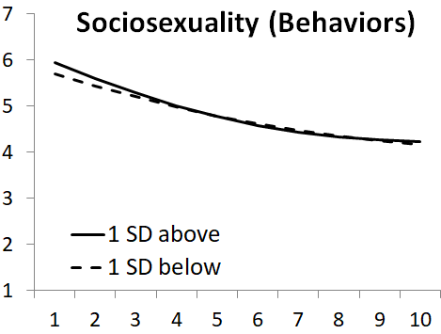
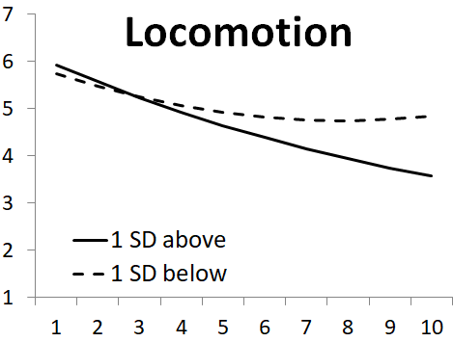
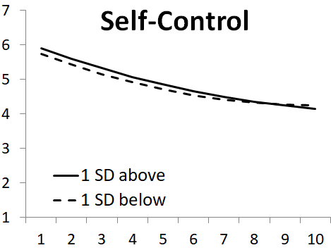
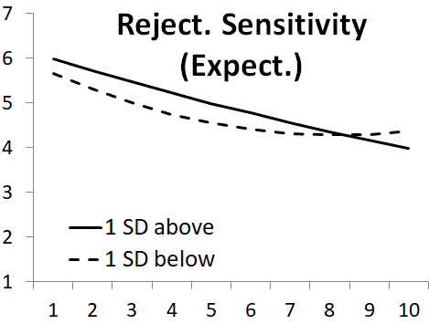
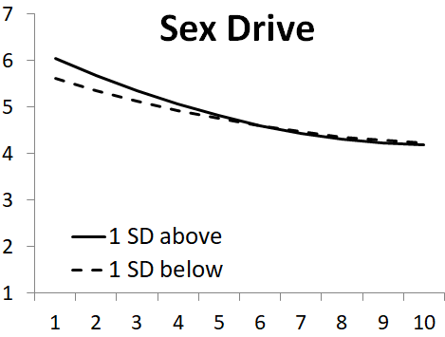
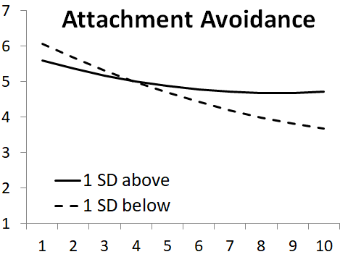
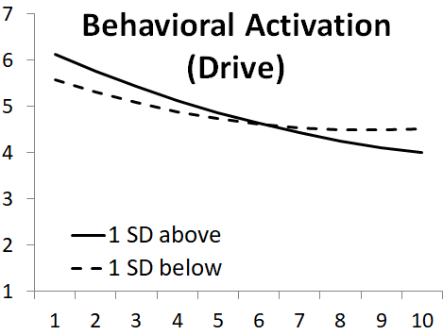

Note: Equation 1 results for the 7 individual-difference predictors that contributed to the significant nested resampling random forests model at the interpretation step in stage 1 (Table S2). Predictors are sorted in the order of the magnitude of the β₁ (wave = 1) effect size.

Romantic Interest
Wave
Figure S2 – Successful Target-Specific Predictors (Dating Subset)
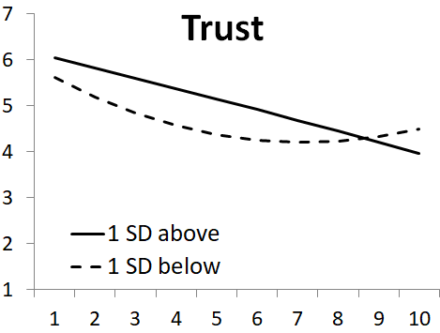
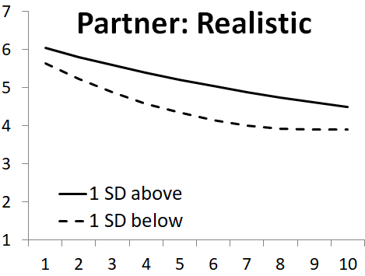
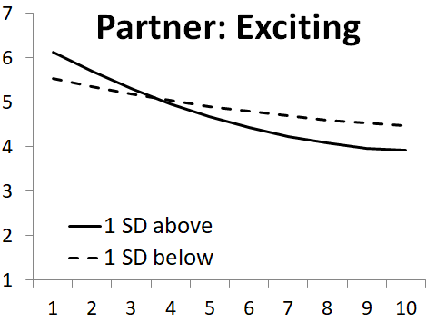
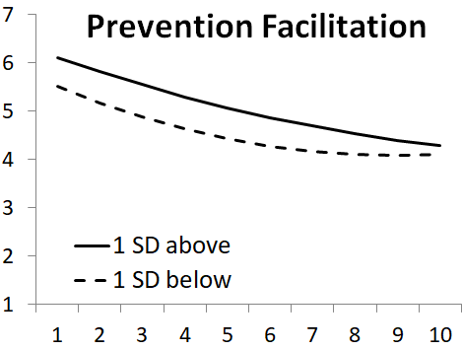
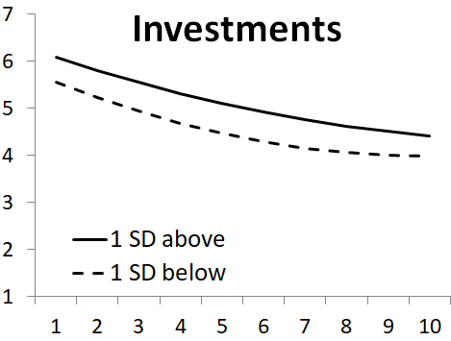
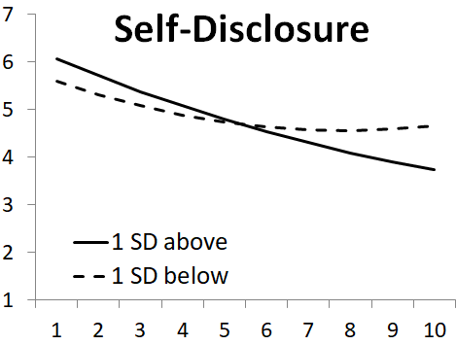
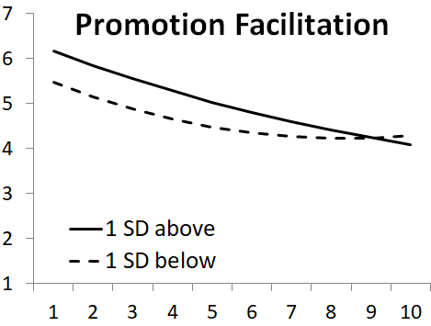
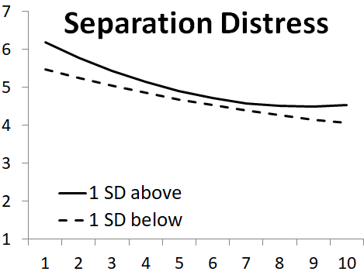
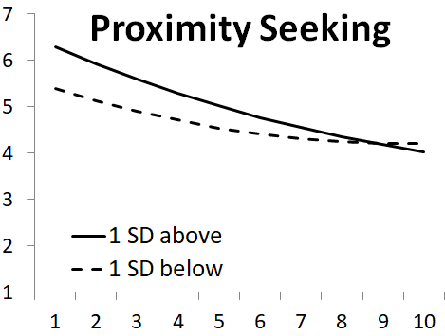
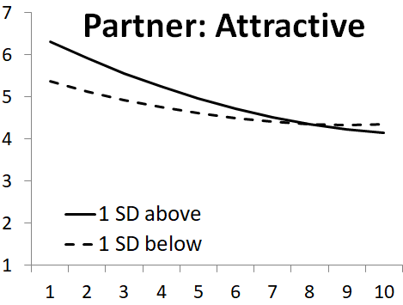

Note: Equation 1 results for the 10 target-specific predictors that contributed to contributed to the significant nested resampling random forests model at the interpretation step in stage 1 (Table S2). Predictors are sorted in the order of the magnitude of the β₁ (wave = 1) effect size.
Wave
Romantic Interest

Table S4 – Equation 1 Results for Individual-Differences Predictors in the Dating Subset
Predictor |  |  | Intercept  β₀ |  | Predictor  β₁ |  | Time  β₂ |  | Time²  β₃ |  | Predictor × Time β₄ |  | Predictor × Time² β₅
 |  | N | B | t | B | t | B | t | B | t | B | t | B | t
Behavioral Activation (Drive) |  | 794 | 5.85 | 36.80*** | 0.28 | 1.72 | -0.33 | -5.80*** | 0.02 | 2.63** | -0.05 | -0.83 | 0.00 | -0.20
Attachment Avoidance |  | 794 | 5.83 | 37.04*** | -0.23 | -1.47 | -0.32 | -5.71*** | 0.02 | 2.42* | 0.08 | 1.41 | 0.00 | 0.05
Sex Drive |  | 794 | 5.83 | 36.64*** | 0.21 | 1.29 | -0.33 | -5.69*** | 0.02 | 2.48* | -0.06 | -1.08 | 0.00 | 0.63
Rejection Sensitivity (Expect.) |  | 794 | 5.82 | 36.69*** | 0.16 | 0.99 | -0.32 | -5.67*** | 0.02 | 2.41* | 0.06 | 1.01 | -0.01 | -1.64
Sociosexuality (Behaviors) |  | 794 | 5.82 | 36.60*** | 0.13 | 0.79 | -0.33 | -5.66*** | 0.02 | 2.44* | -0.05 | -0.89 | 0.00 | 0.70
Locomotion |  | 794 | 5.83 | 36.28*** | 0.09 | 0.56 | -0.33 | -5.77*** | 0.02 | 2.50* | -0.04 | -0.71 | 0.00 | -0.66
Self-Control |  | 794 | 5.82 | 36.68*** | 0.08 | 0.53 | -0.33 | -5.67*** | 0.02 | 2.45* | 0.01 | 0.10 | 0.00 | -0.34

Note: DV = romantic interest (left on the original 1-7 scale). Time was coded 0 = wave 1 through 9 = wave 10. All predictors were standardized. These regressions are graphed in Figure S1. Degrees of freedom for β₁ - β₅ = 678. *p < .05; ** p < .01; *** p < .001.

Table S5 – Equation 1 Results for Target-Specific Predictors in the Dating Subset
Predictor |  |  | Intercept  β₀ |  | Predictor  β₁ |  | Time  β₂ |  | Time²  β₃ |  | Predictor × Time  β₄ |  | Predictor × Time²  β₅
 |  | N | B | t | B | t | B | t | B | t | B | t | B | t
Partner: Attractive |  | 794 | 5.84 | 37.23*** | 0.47 | 2.97** | -0.33 | -5.86*** | 0.02 | 2.65** | -0.08 | -1.40 | 0.002 | 0.30
Proximity Seeking |  | 773 | 5.84 | 36.49*** | 0.44 | 2.75** | -0.32 | -5.64*** | 0.01 | 2.23* | -0.05 | -0.79 | -0.002 | -0.23
Separation Distress |  | 784 | 5.82 | 36.27*** | 0.36 | 2.24* | -0.33 | -5.75*** | 0.02 | 2.67** | -0.10 | -1.79 | 0.010 | 1.50
Promotion Facilitation |  | 770 | 5.82 | 35.79*** | 0.34 | 2.09* | -0.33 | -5.83*** | 0.02 | 2.59** | 0.01 | 0.18 | -0.007 | -1.01
Partner: Exciting |  | 794 | 5.83 | 36.92*** | 0.30 | 1.95 | -0.32 | -5.65*** | 0.02 | 2.37* | -0.14 | -2.41* | 0.008 | 1.24
Prevention Facilitation |  | 770 | 5.81 | 36.12*** | 0.30 | 1.81 | -0.34 | -5.82*** | 0.02 | 2.61** | 0.03 | 0.53 | -0.006 | -0.91
Investments |  | 794 | 5.82 | 37.13*** | 0.26 | 1.65 | -0.33 | -5.65*** | 0.02 | 2.43* | 0.03 | 0.51 | -0.004 | -0.59
Self-Disclosure |  | 773 | 5.82 | 36.54*** | 0.24 | 1.48 | -0.33 | -5.83*** | 0.02 | 2.56* | -0.03 | -0.56 | -0.005 | -0.80
Trust |  | 773 | 5.82 | 36.96*** | 0.22 | 1.41 | -0.34 | -5.96*** | 0.02 | 2.76** | 0.12 | 2.09* | -0.019 | -2.84**
Partner: Realistic |  | 791 | 5.83 | 37.20*** | 0.21 | 1.29 | -0.33 | -5.76*** | 0.02 | 2.54* | 0.09 | 1.65 | -0.009 | -1.47

Note: DV = romantic interest (left on the original 1-7 scale). Time was coded 0 = wave 1 through 9 = wave 10. All predictors were standardized. These regressions are graphed in Figure S2. Degrees of freedom for β₁ - β₅ ranged from 658 to 678 depending on the analysis. *p < .05; ** p < .01; *** p < .001.

Ideal Partner Preference-Matching Analyses in the Dating Subset (Preregistered)
Corrected pattern metric. On the dating subsample, there was no main effect (β₁), but the slope effect (β₄) and curvilinear effect (β₅) went in opposite directions such that ideal partner preference-matching had a positive effect on romantic interest at the middle time points and a negative effect on romantic interest at later time points (Figure S3). Again, if we simply eliminate all the terms involving Time and Time² from the analysis, the overall corrected pattern metric effect (i.e., at the average time point in the sample) is β = -.02, t (682) = -0.18, p = .858 in the dating subsample.
Level metric. Table S3 presents the results of all 14 level metric tests on the dating subsample, sorted again by the strength of the main effect of the trait. Although the ordering of the traits differs from the full sample somewhat, the correlation between the Bs across all 14 trait main effects in Tables S3 and Table 4 in the main text was strong (r = .69); traits that predicted romantic interest in the full sample also tended to predict romantic interest in the dating subsample. Importantly, the 14 level metric analyses again revealed zero significant Ideal × Trait interactions (average β₁ = .03). For slope effects, 2 of 14 level metric effects were significant and positive and 1 of 14 was significant and negative; average β₄ = .029. For curvilinear effects, 1 of 14 level metric effects was significant and positive and 3 of 14 were significant and negative; average β₅= -.005.

Figure S3 – Ideal Partner Preference-Matching Over Time in Dating Subset (Corrected Pattern Metric)

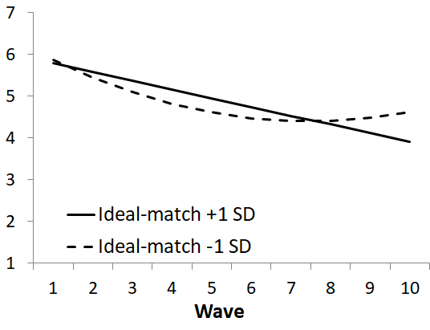

Romantic Interest

Regression term |  | B | t
Intercept β₀ |  | 5.83 | 36.65***
Time β₂ |  | -0.33 | -5.83***
Time² β₃ |  | 0.02 | 2.69**
Pattern metric β₁ |  | -0.03 | -0.21
Pattern metric × Time β₄ |  | 0.12 | 2.10*
Pattern metric × Time² β₅ |  | -0.02 | -2.67**

Note: Italicized rows are the focal pattern metric tests. βs refer to terms in equation 1. N = 794; degrees of freedom for β₁ - β₅ = 678. *p < .05; ** p < .01; *** p < .001

Table S6 – Level Metric Tests of Ideal Partner Preference-Matching (Dating Subset)
Regression term |  | Attractive |  | Ambitious |  | Exciting |  | Supportive |  | Spontaneous |  | Dependable |  | Realistic
 |  | B | t | B | t | B | t | B | t | B | t | B | t | B | t
Intercept β₀ |  | 5.83 | 37.36*** | 5.84 | 37.72*** | 5.83 | 36.43*** | 5.84 | 35.31*** | 5.85 | 36.21*** | 5.83 | 36.29*** | 5.81 | 34.73***
Ideal |  | 0.17 | 1.10 | -0.04 | -0.23 | -0.03 | -0.18 | 0.04 | 0.24 | 0.09 | 0.51 | 0.05 | 0.31 | 0.01 | 0.07
Time β₂ |  | -0.32 | -5.46*** | -0.35 | -5.86*** | -0.30 | -5.15*** | -0.36 | -6.12*** | -0.33 | -5.69*** | -0.35 | -6.05*** | -0.36 | -5.87***
Ideal × Time |  | -0.01 | -0.22 | -0.09 | -1.50 | 0.12 | 2.00* | 0.08 | 1.43 | 0.05 | 0.88 | 0.02 | 0.38 | -0.10 | -1.61
Time² β₃ |  | 0.02 | 2.36* | 0.02 | 2.45* | 0.01 | 1.97* | 0.02 | 2.90** | 0.02 | 2.58* | 0.02 | 2.85** | 0.02 | 2.94**
Ideal × Time² |  | 0.00 | 0.64 | 0.01 | 0.72 | -0.01 | -0.91 | -0.01 | -1.88 | -0.01 | -1.15 | 0.00 | -0.48 | 0.01 | 1.19
Trait |  | 0.42 | 2.68** | 0.31 | 2.00* | 0.31 | 1.92 | 0.26 | 1.63 | 0.25 | 1.51 | 0.23 | 1.39 | 0.22 | 1.22
Trait × Time |  | -0.04 | -0.71 | 0.08 | 1.34 | -0.17 | -2.90** | -0.08 | -1.42 | -0.02 | -0.38 | -0.04 | -0.63 | 0.16 | 2.47*
Trait × Time² |  | 0.00 | -0.36 | -0.01 | -1.25 | 0.01 | 1.40 | 0.01 | 0.83 | 0.00 | 0.33 | 0.00 | 0.06 | -0.02 | -2.23*
Ideal × Trait β₁ |  | 0.15 | 0.96 | 0.00 | 0.00 | -0.01 | -0.04 | 0.06 | 0.34 | -0.16 | -1.16 | 0.06 | 0.36 | 0.07 | 0.48
Ideal × Trait × Time β₄ |  | -0.16 | -2.50* | 0.08 | 1.40 | -0.07 | -1.13 | 0.20 | 3.12*** | -0.04 | -0.73 | 0.23 | 3.91*** | 0.07 | 1.26
Ideal × Trait × Time² β₅ |  | 0.02 | 2.04* | 0.00 | -0.49 | 0.01 | 0.89 | -0.02 | -3.04*** | 0.00 | 0.75 | -0.03 | -4.36*** | -0.01 | -1.53

Regression term |  | Patient |  | Creative |  | Optimistic |  | Passive |  | Level-headed |  | Confident |  | Dominant
 |  | B | t | B | t | B | t | B | t | B | t | B | t | B | t
Intercept β₀ |  | 5.80 | 34.85*** | 5.82 | 35.65*** | 5.83 | 34.48*** | 5.83 | 33.88*** | 5.84 | 34.27*** | 5.78 | 34.12*** | 5.79 | 34.24***
Ideal |  | 0.00 | 0.01 | -0.04 | -0.23 | 0.07 | 0.39 | 0.05 | 0.26 | 0.09 | 0.55 | -0.03 | -0.19 | -0.11 | -0.61
Time β₂ |  | -0.36 | -5.91*** | -0.29 | -4.82*** | -0.34 | -5.68*** | -0.37 | -5.86*** | -0.34 | -5.70*** | -0.29 | -4.61*** | -0.36 | -5.69***
Ideal × Time |  | 0.06 | 0.90 | 0.07 | 1.09 | 0.06 | 0.93 | -0.04 | -0.50 | -0.05 | -0.91 | -0.11 | -1.83 | -0.14 | -2.03
Time² β₃ |  | 0.02 | 2.91** | 0.01 | 1.67 | 0.02 | 2.65** | 0.02 | 3.11** | 0.02 | 2.68** | 0.01 | 1.85 | 0.03 | 3.44***
Ideal × Time² |  | -0.01 | -0.69 | -0.01 | -0.74 | -0.01 | -0.97 | 0.01 | 0.99 | 0.00 | 0.57 | 0.01 | 1.13 | 0.01 | 1.37
Trait |  | 0.19 | 1.06 | 0.17 | 0.98 | 0.17 | 0.91 | 0.15 | 0.80 | 0.12 | 0.64 | 0.05 | 0.27 | -0.05 | -0.25
Trait × Time |  | 0.05 | 0.81 | 0.02 | 0.31 | -0.06 | -0.99 | 0.07 | 0.97 | 0.01 | 0.18 | 0.01 | 0.21 | 0.07 | 1.01
Trait × Time² |  | -0.01 | -1.34 | -0.01 | -1.17 | 0.00 | 0.22 | -0.01 | -1.31 | -0.01 | -1.32 | 0.00 | -0.48 | 0.00 | 0.09
Ideal × Trait β₁ |  | 0.10 | 0.52 | -0.06 | -0.39 | -0.02 | -0.11 | 0.03 | 0.21 | -0.06 | -0.35 | 0.11 | 0.64 | 0.11 | 0.77
Ideal × Trait × Time β₄ |  | 0.09 | 1.47 | -0.08 | -1.52 | 0.04 | 0.85 | 0.08 | 1.65 | 0.05 | 0.81 | -0.12 | -1.74 | 0.03 | 0.63
Ideal × Trait × Time² β₅ |  | -0.01 | -1.58 | 0.01 | 0.83 | -0.01 | -1.45 | -0.01 | -2.05* | -0.01 | -1.12 | 0.01 | 1.14 | -0.01 | -1.74

Note: “Trait” refers to the participants’ perception of the trait in the potential partner. Italicized rows are the focal level metric tests. Columns are sorted in order of decreasing strength of the trait effect. βs refer to terms in equation 1 (other rows are control variables). Depending on the analysis, Ns range from 774 to 794, and degrees of freedom for β₁ - β₅ range from 656 to 674. *p < .05; ** p < .01; *** p < .001.

Additional Ideal Partner Preference Analyses in the Dating Subset (Exploratory)

In this section, we report results for the exploratory analytic approaches in the dating subset. Table S7 contains the results for the raw pattern metric, and Table S8 contains the ideal-trait correlations. None of these findings differ appreciably from those reported on the full sample in Tables 8 and 9 in the main text. We did not calculate functional-summarized preference correlations on the dating subsample, as most participants only dated one potential partner over the course of the study (i.e., the functional preference would not apply across multiple targets, which is part of the definition of the construct; Ledgerwood et al., 2018).

Table S7 – Ideal Partner Preference-Matching, Dating Subsample (Raw Pattern Metric)
Regression term |  | B | t
Intercept β₀ |  | 5.82 | 36.65***
Time β₂ |  | -0.34 | -5.84***
Time² β₃ |  | 0.02 | 2.73**
Pattern metric β₁ |  | 0.18 | 1.09
Pattern metric × Time β₄ |  | 0.01 | 0.16
Pattern metric × Time² β₅ |  | -0.01 | -1.48

Note: Italicized rows are the focal pattern metric tests. βs refer to terms in equation 1. N = 781; degrees of freedom for β₁ - β₅ = 667. ** p < .01; *** p < .001.

Table S8 – Ideal-Trait Correlations, Dating Subsample

Attribute |  | β
Dominant |  | .48***
Passive |  | .46***
Realistic |  | .42***
Confident |  | .31**
Level-headed |  | .30**
Optimistic |  | .30**
Patient |  | .29*
Creative |  | .27*
Ambitious |  | .20
Exciting |  | .20
Supportive |  | .15
Spontaneous |  | .12
Attractive |  | .08
Dependable |  | .08

Note: Attributes are sorted by the (average) size of the ideal-trait standardized beta (β). Depending on the analysis, Ns range from 109 to 112, and degrees of freedom range from 30 to 33. *p < .05; ** p < .01; *** p < .001.

First Target (N = 208) Analyses
 |  |  | Variable selection method
 |  |  | VSURF: Threshold |  |  |  |  | VSURF: Interpret |  |  |  |  |  |  | VSURF: Predict |  |  |  |  |  |  |  |  | Stachl et al. (2020)
 |  |  | OOB |  | 10 × 10-fold cross-validation |  |  | OOB |  | 10 × 10-fold cross-validation |  |  |  |  | OOB |  |  |  | 10 × 10-fold cross-validation |  |  |  |  | Nested  resampling
Romantic Interest DV | Set of predictor variables |  | R² |  | R²  (M) | R²  (SD) |  | R² |  | R²  (M) |  | R²  (SD) |  |  | R² |  |  |  | R²  (M) |  | R²  (SD) |  |  | R²  (M) | R²  (SD)
Initial | Individual-diffs |  | .159 |  | .096* | .146 |  | .209 |  | .159** | .167 |  |  |  | .221 |  |  | .186** |  | .187 |  |  |  | .037 |  | .186
 | Target-specific reports |  | .316 |  | .263*** | .171 |  | .338 |  | .234** | .270 |  |  |  | .338 |  |  | .234** |  | .270 |  |  |  | .200* |  | .282
 | All variables |  | .345 |  | .261*** | .143 |  | .369 |  | .314*** | .172 |  |  |  | .403 |  |  | .355*** |  | .171 |  |  |  | .218** |  | .241
Peak | Individual-diffs |  | .153 |  | .073* | .156 |  | .198 |  | .132** | .176 |  |  |  | .192 |  |  | .083 |  | .236 |  |  |  | .027 |  | .230
 | Target-specific reports |  | .252 |  | .211*** | .201 |  | .276 |  | .232** | .238 |  |  |  | .290 |  |  | .192** |  | .250 |  |  |  | .180*** |  | .193
 | All variables |  | .287 |  | .195*** | .163 |  | .324 |  | .268*** | .197 |  |  |  | .323 |  |  | .236*** |  | .221 |  |  |  | .207** |  | .224
Final | Individual-diffs |  | .114 |  | .064* | .148 |  | .155 |  | .091* | .189 |  |  |  | .131 |  |  | .022 |  | .247 |  |  |  | -.110 |  | .215
 | Target-specific reports |  | .117 |  | .048 | .172 |  | .121 |  | .055 | .179 |  |  |  | .080 |  |  | -.044 |  | .247 |  |  |  | -.086 |  | .191
 | All variables |  | .171 |  | .130*** | .119 |  | .180 |  | .134** | .153 |  |  |  | .191 |  |  | .137** |  | .187 |  |  |  | -.116 |  | .252
Change | Individual-diffs |  | -.021 |  | -.091 | .235 |  | .026 |  | -.124 | .333 |  |  |  | .018 |  |  | -.077 |  | .205 |  |  |  | -.296 |  | .435
 | Target-specific reports |  | -.083 |  | -.208 | .322 |  | -.052 |  | -.208 | .293 |  |  |  | -.052 |  |  | -.208 |  | .293 |  |  |  | -.423 |  | .442
 | All variables |  | -.012 |  | -.059 | .156 |  | .039 |  | -.156 | .345 |  |  |  | .018 |  |  | -.068 |  | .214 |  |  |  | -.305 |  | .333
Table S9 – Machine Learning Analyses Predicting Romantic Interest on the First Target

Note: Variable selection performed using the VSURF liberal (threshold), moderate (interpret), or conservative (predict) selection procedure (Genuer et al., 2015), as well as the Stachl et al. (2020) approach that embeds variable selection in the resampling process. OOB = Out-of-bag. Positive 10 × 10-fold cross-validation and nested resampling mean values were tested for significance against a null model using the Bouckaert and Frank (2004) modified t-test. *p < .05; ** p < .01, *** p < .001.

Table S10 – Significance Tests Corresponding to K-Fold and Nested Resampling R² values in Table S9
Hypothesis | Analysis set |  | VSURF: Threshold |  |  | VSURF: Interpret |  | VSURF: Predict |  | Stachl et al. (2020)
1 | Initial |  | 2.35* |  |  | 0.71 |  | 0.44 |  | 1.52
 | Peak |  | 1.55 |  |  | 1.00 |  | 0.95 |  | 1.41
 | Final |  | -0.20 |  |  | -0.40 |  | -0.57 |  | 0.25
 | Change |  | -0.91 |  |  | -0.57 |  | -1.01 |  | -0.64
2 | Initial |  | -0.03 |  |  | 0.73 |  | 1.10 |  | 0.16
 | Peak |  | -0.17 |  |  | 0.35 |  | 0.40 |  | 0.24
 | Final |  | 1.16 |  |  | 1.00 |  | 1.79 |  | -0.28
 | Change |  | 1.18 |  |  | 0.32 |  | 1.19 |  | 0.60
3 | Individual-diffs |  | 0.42 |  |  | 0.74 |  | 1.47 |  | 1.72
 | Target-specific reports |  | 2.58* |  |  | 1.58 |  | 2.06* |  | 2.42*
 | All variables |  | 1.99* |  |  | 2.21* |  | 2.41* |  | 2.84**

Note: Values are t statistics (on 99 df) from the Bouckaert and Frank (2004) modified t-test used to compare two CV models. *p < .05; ** p < .01.

Random Forests Moderation Simulations
The variable “stacking” approach that we adopted in this study (also used in Großmann et al., 2019; and Joel et al., 2020) potentially permits researchers to draw conclusions about moderation. The logic is as follows: If variables in set A (e.g., individual differences) moderate the effects of variables in set B (e.g., target-specific constructs), then random forests analyses that use sets A&B together as predictors should explain more variance in the DV (i.e., romantic interest) than set B alone. The analyses reported in the main text (and in Großmann et al., 2019; and Joel et al., 2020) failed to document that A&B > B, suggesting that variables in set A do not moderate the effects of the variables in set B.
However, is it true that random forests would be able to recover significant moderation effects using this strategy? To test this idea, we calculated simulated datasets with the following features:
- Set A: Five random variables (e.g., individual differences)
- Set B: Five random variables (e.g., target-specific constructs)
- DV: A dependent measure (e.g., romantic interest)
The DV was generated so that it was a function of the Set A and Set B variables. Specifically:
- The five Set A variables had no effects on the DV, for simplicity (all five Bs = 0)
- The five Set B variables had moderate effects on the DV (average absolute value of Bs = .25, ranging from .15-.35)
- Of the 25 possible Set A × Set B interactions, 20 Bs were set to B = 0. The remaining 5 Bs had small effects on the DV (average absolute value of the five Bs = .15, ranging from .05-.25).
We created 50 simulated datasets that each consisted of N = 500 participants; these participants were randomly sampled based on this “true” distribution information. We then conducted the Random Forests analysis on Set A alone, Set B alone, and Set A&B together. In these analyses, Set A accounted for no variance, as anticipated. (It was actually -5.8%, a negative value which suggests that one is better off simply guessing the grand mean than using the Set A variables to try to predict the DV.) Set B accounted for 16.1% of the variance. Critically, Sets A & B together accounted for 19.4% of the variance, suggesting that the Random Forests models were able to recover the variance accounted for by these interaction effects. Indeed, a paired t-test comparing these two means (16.1 vs. 19.4) across the N = 50 simulated datasets was highly significant, t(49) = 13.59, p < .001, d = 1.95.
The exact code for creating the mock datasets and the subsequent Random Forests analysis (in R) is reproduced below:

#############Generating simulated data##############

##5 individual difference (ID) predictors exert no main effects on the DV
#5 target-specific effects (TS) do exert main effects on the DV
#there are five interactions between individual differences and target-specific effects predicting the DV.

#Adapted from Power Simulation Code from Lane, Hennes, et al (https://osf.io/6hswj/)

target.sim <- function(J) {
person <- rep(1:J) #J is total sample size
x1 <- rnorm(J, mean = 0, sd = 1) #continuous ID x1
x2 <- rnorm(J, mean = 0, sd = 1) #continuous ID x2
x3 <- rnorm(J, mean = 0, sd = 1) #continuous ID x3
x4 <- rnorm(J, mean = 0, sd = 1) #continuous ID x4
x5 <- rnorm(J, mean = 0, sd = 1) #continuous ID x5
x6 <- rnorm(J, mean = 0, sd = 1) #continuous TS x6
x7 <- rnorm(J, mean = 0, sd = 1) #continuous TS x7
x8 <- rnorm(J, mean = 0, sd = 1) #continuous TS x8
x9 <- rnorm(J, mean = 0, sd = 1) #continuous TS x9
x10 <- rnorm(J, mean = 0, sd = 1) #continuous TS x10
b0 <- 1
#Individual differences have no main effects
b1 <- 0
b2 <- 0
b3 <- 0
b4 <- 0
b5 <- 0
#Target specific variables do have main effects
b6 <- .35
b7 <- -.30
b8 <- .25
b9 <- -.20
b10 <- -.15
#Five interaction effects between individual differences and target-specific variables
b11 <- .25
b12 <- -.20
b13 <- .15
b14 <- .10
b15 <- .05
#remaining interactions are set to zero
b16 <- 0
b17 <- 0
b18 <- 0
b19 <- 0
b20 <- 0
b21 <- 0
b22 <- 0
b23 <- 0
b24 <- 0
b25 <- 0
b26 <- 0
b27 <- 0
b28 <- 0
b29 <- 0
b30 <- 0
b31 <- 0
b32 <- 0
b33 <- 0
b34 <- 0
b35 <- 0

y <- rnorm(J, b0 + (b1*x1) + (b2*x2) + (b3*x3) + (b4*x4) + (b5*x5) #null individual differences
+ (b6*x6) + (b7*x7) + (b8*x8) + (b9*x9) + (b10*x10) #target-specific main effects
+ (b11*x1*x6) + (b12*x2*x7) + (b13*x3*x8) + (b14*x4*x9) + (b15*x5*x10) #real interactions
+ (b16*x1*x7) + (b17*x1*x8) + (b18*x1*x9) + (b19*x1*x10) #null interactions
+ (b20*x2*x6) + (b21*x2*x8) + (b22*x2*x9) + (b23*x2*x10)
+ (b24*x3*x6) + (b25*x3*x7) + (b26*x3*x9) + (b27*x3*x10)
+ (b28*x4*x6) + (b29*x4*x7) + (b30*x4*x8) + (b31*x4*x10)
+ (b32*x5*x6) + (b33*x5*x7) + (b34*x5*x8) + (b35*x5*x9)
+ (sqrt(1-b6*b6+b7*b7+b8*b8+b9*b9+b10*b10+b11*b11+b12*b12+b13*b13+b14*b14+b15*b15))) #error term

return(data.frame(person,y,x1,x2,x3,x4,x5,x6,x7,x8,x9,x10)) #return a dataframe with your subject variable, their y value, and all their x values
}

target.sim(500) #shows simulated data for 500 Ps

##########Machine learning on simulated data#############

require(randomForest)

#This loop conducts random forest models for each simulated dataset
#DV is predicted from individual differences (ID), target-specific (TS), and both combined (Both)

values.loop <- function(simnum){
IDvariance<-data.frame("IDvariance"=1:simnum)
TSvariance<-data.frame("TSvariance"=1:simnum)
Bothvariance<-data.frame("Bothvariance"=1:simnum)
simulation<-data.frame("simulation"=1:simnum)

for(i in 1:simnum){dataset <- target.sim(500)
IDmodel <- randomForest(y~x1 + x2 + x3 + x4 + x5, data=dataset, importance=T, na.action=na.omit, parallel=TRUE, ntree=5000)
IDVar <- 100*(IDmodel$rsq[5000])
TSmodel <- randomForest(y~x6 + x7 + x8 + x9 + x10, data=dataset, importance=T, na.action=na.omit, parallel=TRUE, ntree=5000)
TSVar <- 100*(TSmodel$rsq[5000])
Bothmodel <- randomForest(y~x1 + x2 + x3 + x4 + x5 + x6 + x7 + x8 + x9 + x10, data=dataset, importance=T, na.action=na.omit, parallel=TRUE, ntree=5000)
BothVar <- 100*(Bothmodel$rsq[5000])
IDvariance[i,] <- IDVar
TSvariance[i,] <- TSVar
Bothvariance[i,] <- BothVar
}

variance_frame <-cbind(simulation,IDvariance,TSvariance,Bothvariance)
variance_frame
}

Random Forests Analyses with State Self-Reports
Table S11 – State Self-Report Variables
Construct |  | Example item
Agitated mood |  | I feel agitated these days.
Approach goals |  | Right now, I am striving to enhance bonding and intimacy in my relationships with others.
Assessment |  | I put a lot of time into considering various options before making a decision.
Autonomy |  | I feel that I am free to choose my own path in life.
Avoidance goals |  | Right now, I am striving to avoid disagreements and conflicts in my relationships with others.
Calm mood |  | I feel calm these days.
Competence |  | I feel that I am capable of achieving my goals.
Depression |  | Over the past week I felt depressed.
Embarrassment concern |  | I feel I'll say something embarrassing when talking.
Exclusion |  | Over the past three weeks, did you ever feel socially excluded?
Gain focus |  | Recently, I've been thinking a lot about doing what I can to move forward and accomplish what I want.
Happy mood |  | I feel happy these days.
Health (overall) |  | Right now, I would say that my health is: [poor...excellent]
Isolation |  | I feel isolated from others.
Locomotion |  | When I decide to do something, I can't wait to get started.
Loneliness |  | I lack companionship.
Loss focus |  | Recently, I've been thinking a lot about doing what is necessary to stay safe and obtain what I need.
Mate value |  | Lately, I seem to have a lot of romantic appeal to others.
Meeting attempts |  | Over the past three weeks, did you ever actually attempt to meet someone new?
Meeting intention |  | Over the past three weeks, did you ever have the specific intention to try to meet someone new?
Meeting motivation |  | Over the past three weeks, did you ever think about wanting to meet someone new?
Meeting success |  | Over the past three weeks, did you ever succeed in meeting someone new?
Need to belong |  | Socially, I have a strong "need to belong."
Nongain focus |  | Recently, I've been thinking a lot about making sure I don't miss any opportunities to accomplish what I want.
Nonloss focus |  | Recently, I've been thinking a lot about making sure I don't do anything to threaten my ability to obtain what I need.
Prevention focus |  | My primary focus in life is to fulfill my duties and responsibilities.
Promotion focus |  | My primary focus in life is to fulfill my hopes and aspirations.
Rejection sensitivity |  | I am concerned or anxious about whether I will be rejected in social situations.
Relatedness |  | My relationships with people in general are satisfying.
Romantic success |  | I have experienced considerable romantic success lately.
Sad mood |  | I feel sad these days.
Self-concept clarity |  | In general, I have a clear sense of who and what I am.
Self-control |  | I am able to resist temptation and work effectively toward long-term goals.
Self-esteem |  | I have high self-esteem.
Sleep quality |  | During the past three weeks, I would rate my overall sleep quality as: [very bad…very good]
Social anxiety |  | When mixing socially I am uncomfortable.
Subjective well-being |  | I am satisfied with my life.
Note: Response options other than numerical rating scales are presented after the example items in brackets.

Table S12 – Random Forests Analyses on the Full Sample (OOB Estimates)
 | Individual differences | Target-specific | Individual differences & Target-specific | State | Individual-differences & State | Target-specific & State | All Three Sets
Initial-report
Threshold | 10.73 | 36.14 | 40.83 | 3.07 | 9.02 | 37.16 | 40.81
Interpret | 16.82 | 37.17 | 43.43 | 7.71 | 15.98 | 39.32 | 43.64
Predict | 17.52 | 37.17 | 43.62 | 4.87 | 15.98 | 39.54 | 43.89
Peak
Threshold | 6.97 | 28.80 | 34.85 | -5.22 | 0.26 | 29.35 | 33.99
Interpret | 14.41 | 30.11 | 37.69 | 6.85 | 14.41 | 30.75 | 37.84
Predict | 14.41 | 31.35 | 37.59 | 5.70 | 14.41 | 33.58 | 38.00
Final-report
Threshold | -7.04 | 4.39 | 7.49 | -1.24 | -2.51 | 10.46 | 10.97
Interpret | 7.44 | 6.82 | 9.74 | 5.39 | 8.17 | 14.71 | 13.09
Predict | 7.44 | 7.67 | 9.74 | 4.80 | 8.17 | 9.18 | 16.29
Change
Threshold | -19.00 | -2.80 | -9.19 | -8.79 | -16.66 | -1.08 | -8.01
Interpret | -2.07 | 0.25 | 2.44 | -0.78 | -2.07 | 0.45 | 0.67
Predict | -2.07 | 0.25 | 1.74 | -0.78 | -2.07 | 0.45 | 0.67

Note: The Individual differences, Target-specific, and Individual differences & Target-specific columns correspond to Table 2 in the main text.

Table S13 – Random Forests Analyses on the Dating Subsample (OOB Estimates)
 | Individual differences | Target-specific | Individual differences & Target-specific | State | Individual-differences & State | Target-specific & State | All Three Sets
Initial-report
Threshold | -4.26 | 28.88 | 23.78 | -6.96 | -3.31 | 26.34 | 23.67
Interpret | 14.17 | 33.95 | 36.58 | 8.95 | 12.47 | 33.49 | 36.27
Predict | 24.49 | 36.53 | 38.54 | 2.40 | 24.20 | 36.77 | 38.54
Peak
Threshold | 3.79 | 16.91 | 15.89 | 0.81 | 5.69 | 18.91 | 14.55
Interpret | 19.54 | 24.43 | 26.79 | 7.37 | 20.68 | 27.18 | 26.76
Predict | 21.32 | 27.97 | 27.51 | 7.37 | 22.19 | 25.82 | 30.69
Final-report
Threshold | -11.55 | 15.71 | 11.90 | 7.50 | 12.58 | 23.25 | 22.24
Interpret | 11.83 | 16.30 | 21.43 | 15.81 | 24.30 | 24.24 | 28.57
Predict | 10.49 | 13.96 | 19.70 | 14.32 | 23.06 | 24.24 | 28.57
Change
Threshold | -0.53 | 2.97 | 3.67 | -8.38 | 1.20 | -0.74 | 4.57
Interpret | 12.34 | 9.53 | 19.24 | 1.37 | 14.72 | 8.57 | 21.03
Predict | 12.34 | 9.53 | 25.43 | 9.25 | 14.30 | 9.53 | 25.87

Note: The Individual differences, Target-specific, and Individual differences & Target-specific columns correspond to Table S2 above.

Table S14 – Stachl et al. (2020) Nested Resampling Method Using Three Different Missing Data Imputation Approaches

 |  |  | Missing data imputation method
Romantic Interest DV | Set of predictor variables |  | Median substitution  (R²) |  | Bagging regr. trees  (R²) |  | k-nearest neighbors  (R²)
Initial | Individual-diffs |  | .081 |  | .031 |  | .031
 | Target-specific reports |  | .321 |  | .305 |  | .326
 | All variables |  | .371 |  | .318 |  | .307
Peak | Individual-diffs |  | .049 |  | .008 |  | .006
 | Target-specific reports |  | .255 |  | .243 |  | .242
 | All variables |  | .295 |  | .253 |  | .261
Final | Individual-diffs |  | -.083 |  | -.008 |  | -.014
 | Target-specific reports |  | -.015 |  | -.005 |  | .027
 | All variables |  | .046 |  | .037 |  | .038
Change | Individual-diffs |  | -.256 |  | -.117 |  | -.116
 | Target-specific reports |  | -.080 |  | -.036 |  | -.048
 | All variables |  | -.121 |  | -.041 |  | -.038

Note: “Median substitution” values are identical to those reported in the Stachl et al. (2020) column in Table 2 in the main text.

Ideal-Partner Preference Matching: Response Surface Analyses
The classic moderation approach to testing ideal partner preference matching is reported in the main text (i.e., ideal × trait interactions; the level metric, Eastwick et al., 2019). However, this is not the only way that matching approaches can be tested. Response surface analysis (Humberg et al., 2019; Weidmann et al., 2017) is an alternative approach that can test whether congruence or similarity between two variables (in this case, between the ideal and the trait) predicts higher romantic interest scores. In the current dataset, both the ideal and the trait were assessed on rating scales ranging from 1 (strongly disagree) to 7 (strongly agree). Thus, we can conduct response surface analyses on these measures (one-trait-at-a-time) to see if, for example, a participant who reports an ideal of a “4” receives an extra romantic interest boost when they perceive that partner to be a “4” on that trait.
We conducted response surface analysis using the RSA package in R (Schönbrodt & Humberg, 2021) predicting the initial romantic interest value across the N = 1,065 target-reports, separately for each of the 14 traits. As outlined in Humberg et al. (2019), we rescaled the values of both the x and y axes to range from -3 to 3 (i.e., centered on 0), and we followed their procedures for determining whether a congruence effect is justified. Results are depicted in the table below. None of the 14 analyses supported a congruence effect. Of the steps described by Humberg et al. (2019), all 14 analyses fail the “a4 must be negative” test, which means that the shape of the response surface above the LOIC was never an inverted U-shaped parabola. Several of the analyses failed other essential tests, too (in 8 of the 14 analyses, a3 ≠ 0). Perusal of the figures (panels A-N below) suggests that in no case was there a “ridge” such that similar x and y values were associated with a boost in romantic interest. In short, then, a response surface analysis also failed to provide support for ideal partner preference matching.
Table S15 – Response Surface Analyses for the 14 Traits
Model | Trait | Position of First Principal Axis |  |  | Shape of Surface Along Lines |  |  |  |  | Congruence Effect Supported?
 |  | p10 | p11 |  | a1 | a2 | a3 | a4
A | Physically Attractive | -184.98 | -6.48 |  | 0.70*** | 0.04 | -0.24 | 0.06 |  | No | a4 not < 0
B | Ambitious | -6.60 | 0.38 |  | -0.05 | 0.10* | -0.30** | 0.04 |  | No | a4 not < 0, a3 ≠ 0
C | Dependable | 505.60 | -79.77 |  | -0.23 | 0.07 | -0.22* | 0.08 |  | No | a4 not < 0
D | Confident | 12.23 | 0.87 |  | -0.35* | 0.16*** | -0.31* | -0.02 |  | No | a4 not < 0, a3 ≠ 0
E | Dominant | 1.18 | -3.58 |  | -0.01 | 0.08** | -0.04 | 0.12*** |  | No | a4 not < 0
F | Passive | -15.32 | 6.60 |  | -0.04 | 0.05 | -0.16** | 0.05 |  | No | a4 not < 0, a3 ≠ 0
G | Exciting | -10.59 | 0.87 |  | 0.09 | 0.10* | -0.27* | 0.03 |  | No | a4 not < 0, a3 ≠ 0
H | Spontaneous | -0.66 | 0.59 |  | -0.16 | 0.15*** | -0.13 | 0.12* |  | No | a4 not < 0
I | Supportive | 17.26 | 0.84 |  | -0.28 | 0.08 | -0.35* | -0.02 |  | No | a4 not < 0, a3 ≠ 0
J | Optimistic | -24.79 | 2.83 |  | -0.18 | 0.12* | -0.18 | 0.04 |  | No | a4 not < 0
K | Realistic | -9.25 | 0.67 |  | -0.18 | 0.15*** | -0.26* | 0.03 |  | No | a4 not < 0, a3 ≠ 0
L | Creative | 4.29 | -0.05ª |  | 0.11 | 0.02 | -0.39*** | 0.04 |  | No | p 11 ≠ 1, a4 not < 0, a3 ≠ 0
M | Patient | 119.42 | 13.61 |  | -0.13 | 0.05 | -0.21* | 0.04 |  | No | a4 not < 0, a3 ≠ 0
N | Level-headed | 3.08 | 2.49 |  | -0.06 | 0.06 | -0.08 | -0.04 |  | No | a4 not < 0

Note: Congruence effect supported column follows the recommended tests as outlined in Humberg et al. (2019). For the a1-a4 parameters, *p < .05; ** p < .01; *** p < .001. For the p11 column, ª indicates that the parameter is significantly different from 1.

Figure S4 – Response Surface Analysis Results from Table S15
B
A

C
D
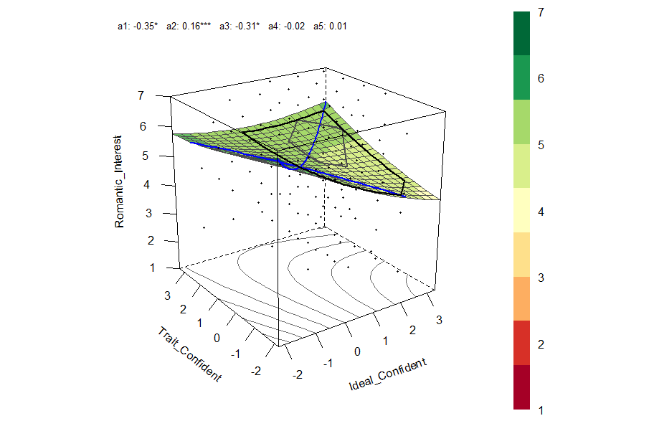
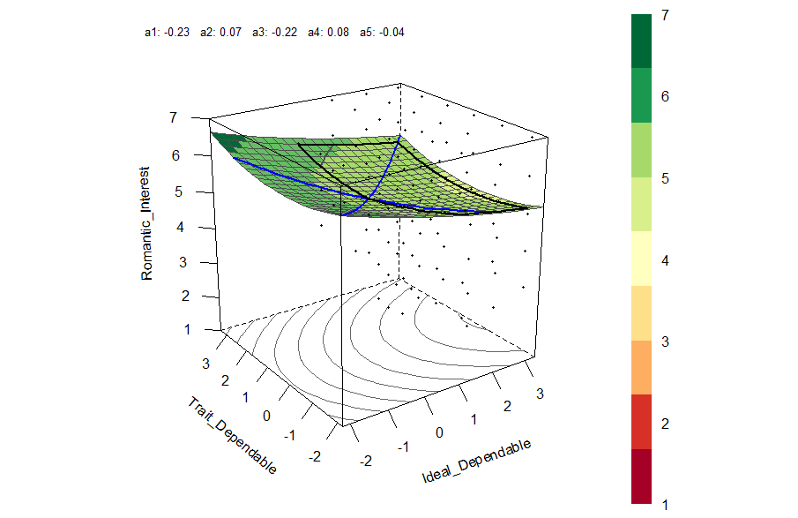
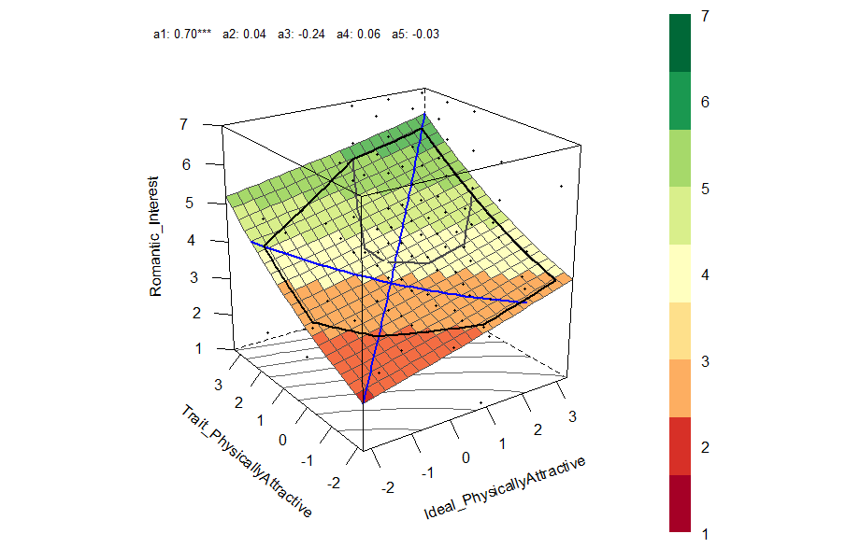
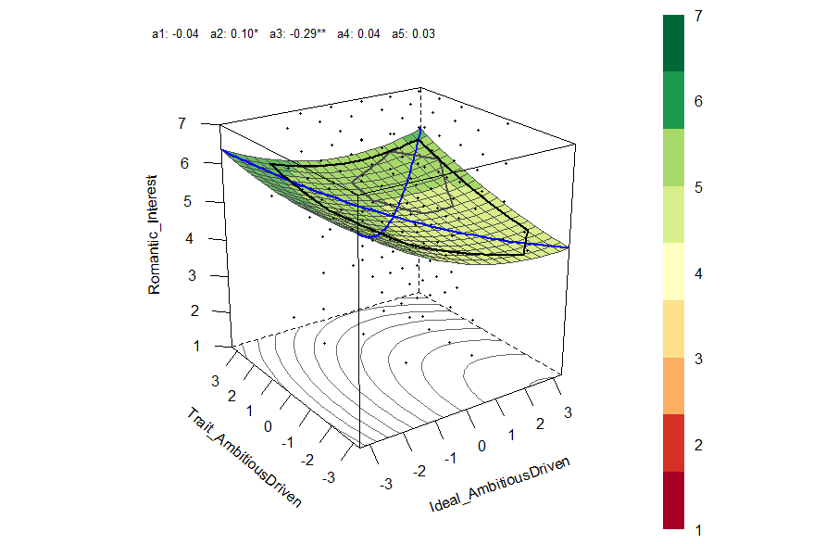
G
H
E
F
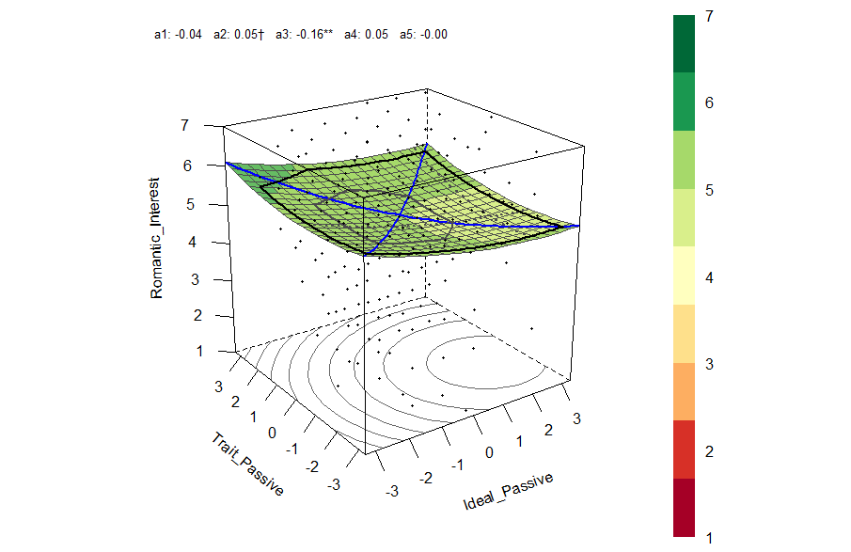
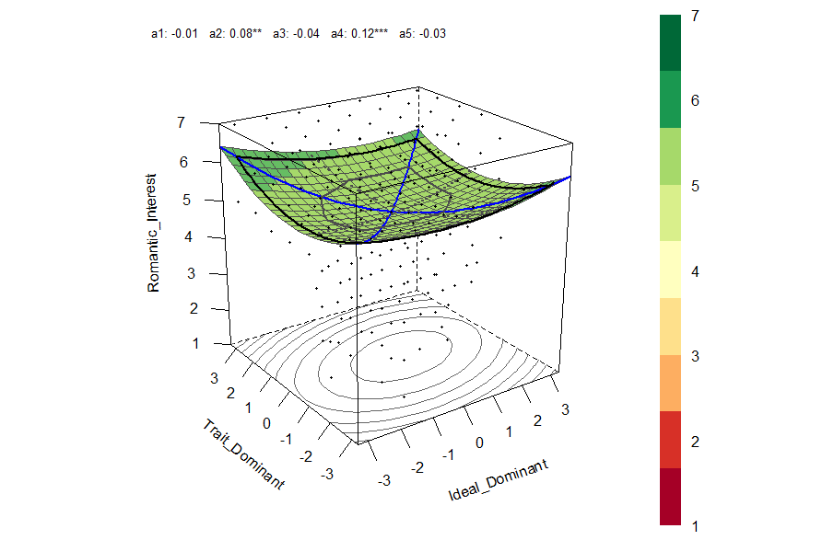
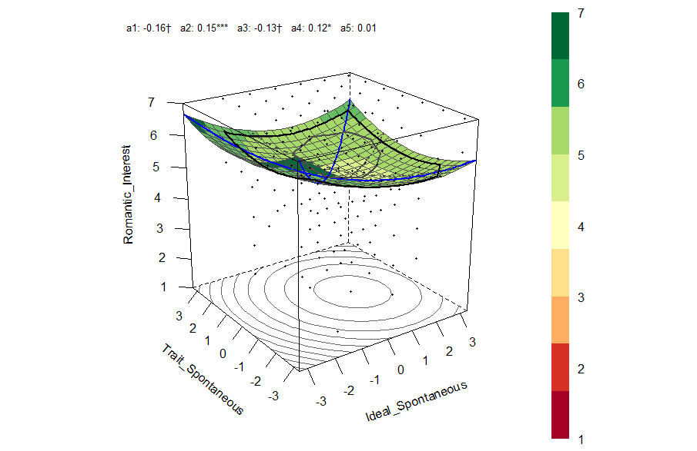
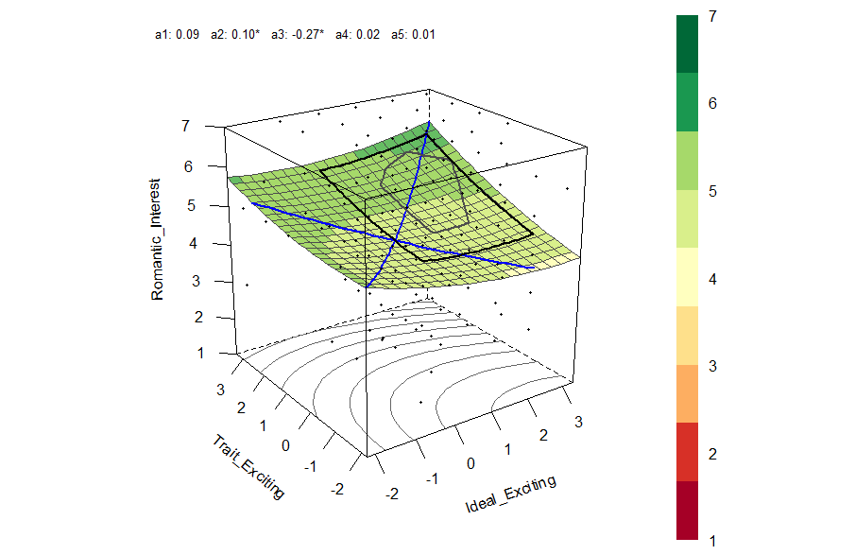
J
I
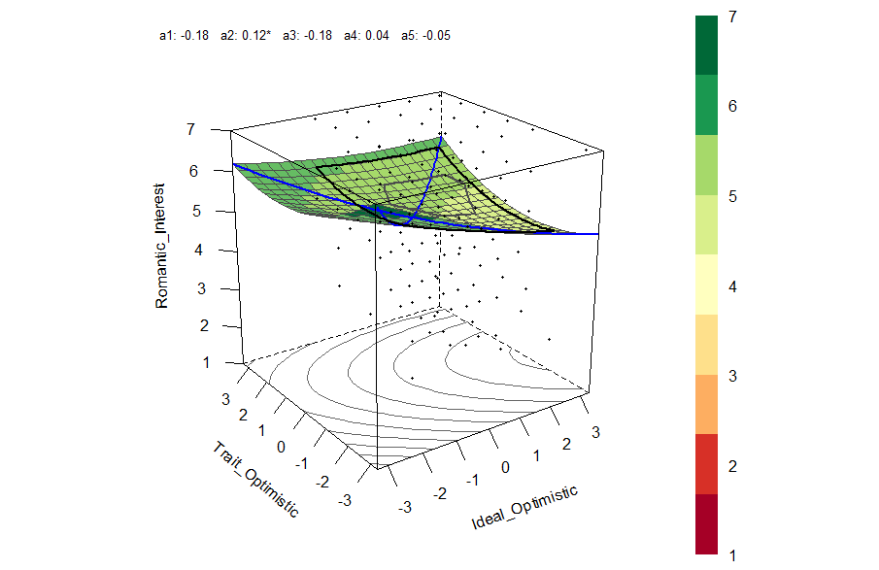
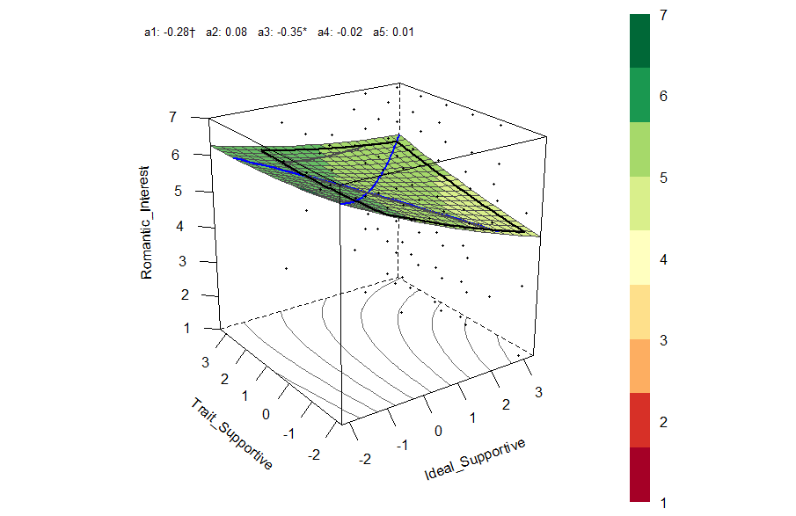
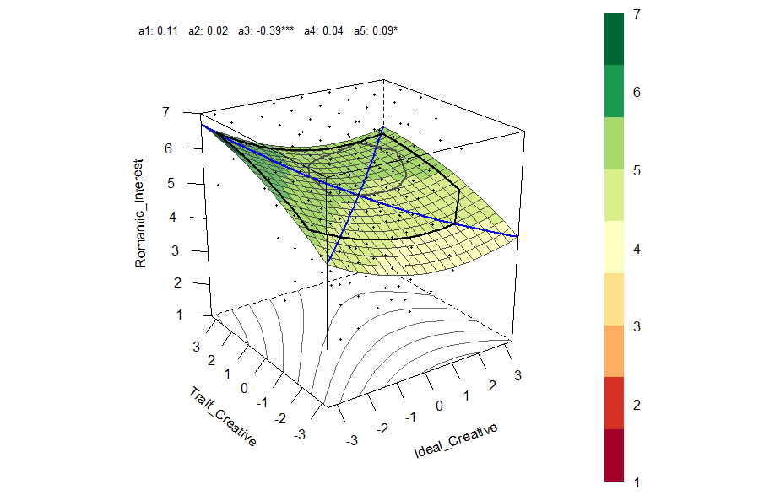
L
K
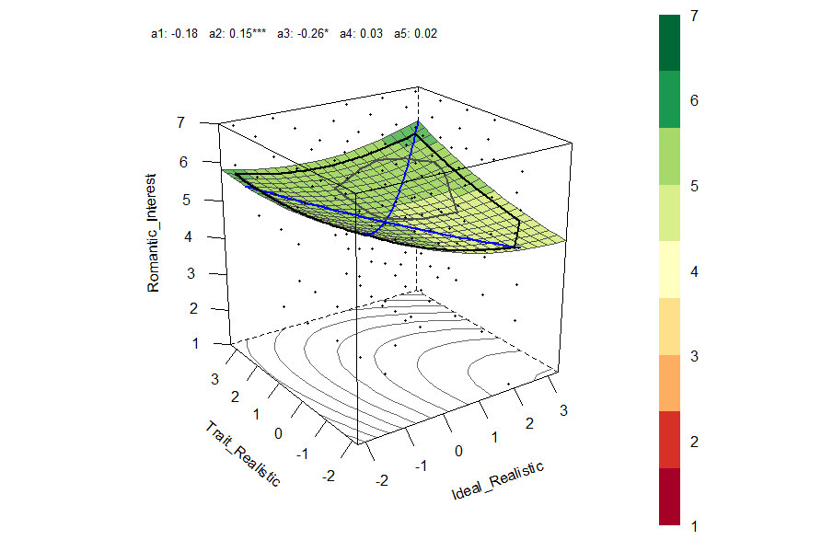
N
M
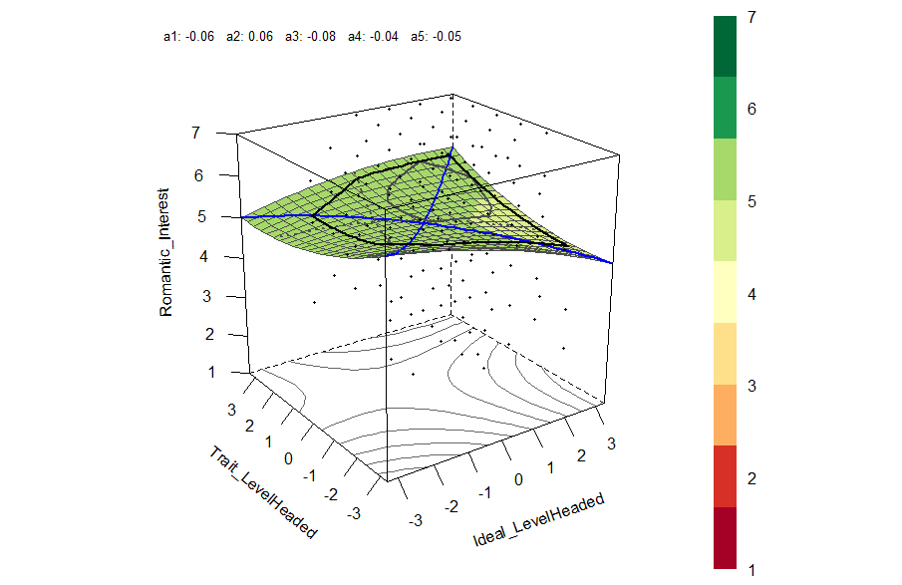
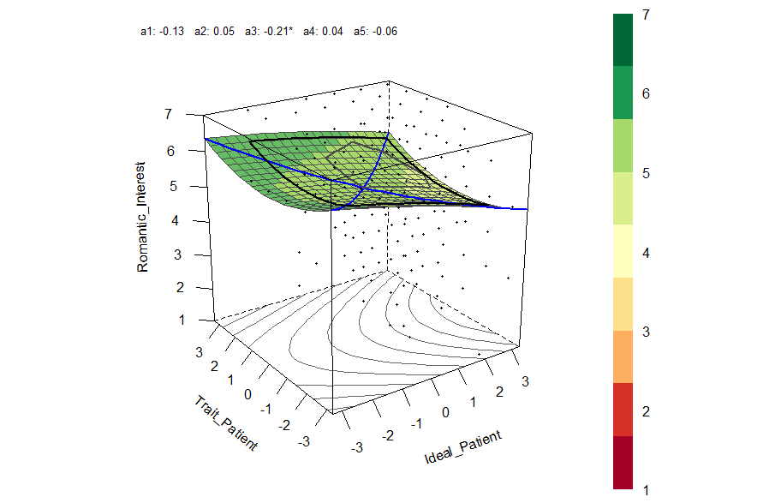

Table S16 – Equation 1 Results for Individual-Differences Predictors from Table 5 Accounting for Missing Predictor Data
Predictor |  | Intercept  β₀ |  | Predictor  β₁ |  | Time  β₂ |  | Time²  β₃ |  | Predictor × Time β₄ |  | Predictor × Time² β₅
 |  | B | t | B | t | B | t | B | t | B | t | B | t
Sex Drive |  | 5.03 | 88.84*** | 0.31 | 5.14*** | -0.46 | -18.63*** | 0.03 | 10.56*** | -0.04 | -1.65 | 0.005 | 1.95
Ideal Partner: Attractive |  | 5.03 | 89.21*** | 0.31 | 5.81*** | -0.46 | -18.71*** | 0.03 | 10.52*** | -0.05 | -1.95 | 0.005 | 1.55
Sociosexuality (Desire) |  | 5.02 | 88.38*** | 0.30 | 4.87*** | -0.46 | -18.55*** | 0.03 | 10.47*** | 0.01 | 0.63 | 0.000 | -0.06
Casual Sex Disapproval (Friends) |  | 5.03 | 86.51*** | -0.22 | -3.51*** | -0.46 | -18.50*** | 0.03 | 10.51*** | 0.00 | 0.05 | -0.002 | -0.69
PDA Approval |  | 5.04 | 87.18*** | 0.20 | 3.52*** | -0.46 | -18.88*** | 0.03 | 10.61*** | -0.06 | -2.21* | 0.005 | 1.70
Weight |  | 5.03 | 86.13*** | 0.18 | 2.93** | -0.47 | -18.52*** | 0.03 | 10.49*** | 0.01 | 0.52 | 0.000 | 0.00
Sociosexuality (Attitudes) |  | 5.03 | 85.73*** | 0.18 | 3.02** | -0.46 | -18.52*** | 0.03 | 10.47*** | 0.01 | 0.55 | -0.001 | -0.21
Narcissism |  | 5.03 | 85.00*** | 0.15 | 2.41* | -0.46 | -18.78*** | 0.03 | 10.58*** | -0.05 | -1.79 | 0.005 | 1.71
Mate Value |  | 5.04 | 85.34*** | 0.14 | 2.51* | -0.47 | -18.53*** | 0.03 | 10.49*** | -0.01 | -0.35 | 0.000 | -0.04
Control Over Passion |  | 5.04 | 85.59*** | 0.14 | 2.36* | -0.46 | -19.01*** | 0.03 | 10.74*** | -0.06 | -2.30* | 0.007 | 2.38*
Self-Concept Clarity |  | 5.03 | 84.20*** | 0.04 | 0.66 | -0.46 | -18.52*** | 0.03 | 10.47*** | 0.00 | 0.13 | 0.001 | 0.41
Power |  | 5.03 | 84.03*** | 0.01 | 0.16 | -0.47 | -18.52*** | 0.03 | 10.51*** | 0.00 | 0.03 | -0.002 | -0.51

Note: DV = romantic interest (left on the original 1-7 scale). Time was coded 0 = wave 1 through 9 = wave 10. All predictors were standardized. Maximum likelihood estimation was carried out using Mplus Version 8.6 (Muthen & Muthen, 1998-2021) in which the covariates were assumed to be random and normally distributed variables. Bolded variables have significant predictor β₁ main effects after conducting a Bonferroni-Holm correction across the 12 β₁ values (Holm, 1979; Stachl, Au, et al., 2020). Asterisks refer to uncorrected p values: *p < .05; ** p < .01; *** p < .001.

Table S17 – Equation 1 Results for Target-Specific Predictors from Table 6 Accounting for Missing Predictor Data
Predictor |  | Intercept  β₀ |  | Predictor  β₁ |  | Time  β₂ |  | Time²  β₃ |  | Predictor × Time  β₄ |  | Predictor × Time²  β₅
 |  | B | t | B | t | B | t | B | t | B | t | B | t
Partner: Attractive |  | 5.04 | 102.49*** | 0.57 | 15.90*** | -0.47 | -18.85*** | 0.03 | 10.71*** | -0.05 | -2.06* | 0.000 | 0.15
Proximity Seeking |  | 5.03 | 87.45*** | 0.43 | 10.37*** | -0.46 | -18.53*** | 0.03 | 10.48*** | -0.04 | -1.45 | 0.002 | 0.73
Perceived Interest |  | 5.02 | 87.56*** | 0.36 | 6.79*** | -0.46 | -18.43*** | 0.03 | 10.42*** | -0.03 | -1.23 | 0.004 | 1.40
Separation Distress |  | 5.02 | 83.41*** | 0.35 | 9.42*** | -0.46 | -18.51*** | 0.03 | 10.50*** | -0.06 | -2.63** | 0.006 | 2.23*
Partner: Exciting |  | 5.03 | 86.64*** | 0.29 | 7.18*** | -0.47 | -18.61*** | 0.03 | 10.51*** | -0.06 | -2.15* | 0.004 | 1.47
Secure Base |  | 5.02 | 84.60*** | 0.29 | 7.14*** | -0.46 | -18.42*** | 0.03 | 10.44*** | -0.02 | -0.82 | 0.003 | 0.93
Self-Disclosure |  | 5.03 | 86.88*** | 0.29 | 6.78*** | -0.46 | -18.71*** | 0.03 | 10.51*** | -0.05 | -1.88 | 0.005 | 1.59
Mixed Signals |  | 5.03 | 90.15*** | 0.28 | 5.61*** | -0.47 | -18.42*** | 0.03 | 10.42*** | -0.05 | -1.72 | 0.004 | 1.28
Prevention Facilitation |  | 5.02 | 85.01*** | 0.25 | 5.43*** | -0.46 | -18.51*** | 0.03 | 10.46*** | 0.00 | 0.07 | 0.000 | 0.00
Investments |  | 5.02 | 84.71*** | 0.23 | 5.58*** | -0.46 | -18.59*** | 0.03 | 10.50*** | 0.02 | 0.71 | -0.002 | -0.67
Trust |  | 5.03 | 86.66*** | 0.23 | 4.75*** | -0.47 | -18.59*** | 0.03 | 10.53*** | 0.00 | 0.09 | -0.001 | -0.34
Relative Power |  | 5.04 | 85.33*** | -0.22 | -4.42*** | -0.47 | -18.68*** | 0.03 | 10.54*** | 0.04 | 1.17 | -0.003 | -0.99
Partner-Disclosure |  | 5.03 | 84.72*** | 0.20 | 4.23*** | -0.46 | -18.51*** | 0.03 | 10.46*** | -0.07 | -2.48* | 0.009 | 2.65**
Partner: Ambitious |  | 5.03 | 85.89*** | 0.18 | 4.16*** | -0.46 | -18.52*** | 0.03 | 10.50*** | 0.00 | -0.13 | 0.001 | 0.24
Partner: Creative |  | 5.03 | 85.09*** | 0.18 | 3.87*** | -0.46 | -18.56*** | 0.03 | 10.46*** | 0.03 | 1.14 | -0.003 | -1.05
Partner: Supportive |  | 5.03 | 84.57*** | 0.16 | 3.50*** | -0.47 | -18.54*** | 0.03 | 10.52*** | -0.01 | -0.23 | 0.000 | -0.06
Partner: Level-Headed |  | 5.04 | 85.13*** | 0.16 | 3.13** | -0.47 | -18.56*** | 0.03 | 10.52*** | 0.00 | -0.14 | -0.001 | -0.44
Partner: Confident |  | 5.03 | 84.75*** | 0.13 | 3.28** | -0.46 | -18.59*** | 0.03 | 10.49*** | -0.03 | -1.11 | 0.001 | 0.44
Partner: Optimistic |  | 5.03 | 85.42*** | 0.13 | 2.98** | -0.46 | -18.50*** | 0.03 | 10.46*** | -0.02 | -0.58 | 0.001 | 0.34
Partner: Dependable |  | 5.03 | 84.52*** | 0.12 | 2.50* | -0.47 | -18.60*** | 0.03 | 10.54*** | 0.03 | 1.14 | -0.004 | -1.49
Partner: Dominant |  | 5.03 | 84.35*** | 0.08 | 1.71 | -0.47 | -18.58*** | 0.03 | 10.51*** | -0.02 | -0.60 | 0.002 | 0.69
Desirable Alternatives |  | 5.03 | 84.38*** | 0.08 | 1.31 | -0.47 | -18.52*** | 0.03 | 10.49*** | -0.01 | -0.40 | 0.002 | 0.46

Note: DV = romantic interest (left on the original 1-7 scale). Time was coded 0 = wave 1 through 9 = wave 10. All predictors were standardized. Maximum likelihood estimation was carried out using Mplus Version 8.6 (Muthen & Muthen, 1998-2021) in which the covariates were assumed to be random and normally distributed variables. Bolded variables have significant predictor β₁ main effects after conducting a Bonferroni-Holm correction across the 22 β₁ values (Holm, 1979; Stachl, Au, et al., 2020). Asterisks refer to uncorrected p values: *p < .05; ** p < .01; *** p < .001.

Example code for Table S16
TITLE: MateValue
DATA:
FILE IS "U:\Documents\Projects\UC Colleagues\PE.csv";
Define: time0sq = timezero*timezero;
VARIABLE:
names are
ID Rom
MateVal
timezero Target;

usevar =
ID Rom MateVal timezero Target time0sq;

CLUSTER = ID Target; !id level 3 Target level 2

WITHIN = timezero time0sq;

BETWEEN =(ID) MateVal;

VARIABLE:
MISSING IS .;

ANALYSIS: TYPE = THREELEVEL RANDOM;

MODEL:
%WITHIN%
s1 | Rom on timezero;
s2 | Rom on time0sq;

%BETWEEN Target%

s1@0;
s2@0;

%BETWEEN ID%
Rom s1 s2 ON MateVal;
MateVal;
s1@0;
s2@0;

OUTPUT: TECH1 TECH8;

Example code for Table S17
TITLE: Attractive

DATA:
FILE IS "U:\Documents\Projects\UC Colleagues\PE.csv";

Define: time0sq = timezero*timezero;

VARIABLE:
names are
ID Rom
Attrac
timezero Target;

usevar =
ID Rom Attrac timezero Target time0sq;

CLUSTER = ID Target; !id level 3 Target level 2

WITHIN = timezero time0sq;

BETWEEN =(Target) Attrac;

VARIABLE:
MISSING IS .;

ANALYSIS: TYPE = THREELEVEL RANDOM;

MODEL:
%WITHIN%
s1 | Rom on timezero;
s2 | Rom on time0sq;

%BETWEEN Target%

Rom s1 s2 ON Attrac;
Attrac;
s1@0;
s2@0;

%BETWEEN ID%
s1@0;
s2@0;

OUTPUT: TECH1 TECH8;
Ideal-Partner Preference Matching: Warmth/Trustworthiness and Vitality/Attractiveness
When participants report their ideal partner preferences for various attributes, their ratings often factor into one of three broader attribute constructs: warmth/trustworthiness, vitality/attractiveness, and status/resources (Fletcher et al., 1999). The traits that we chose to assess in this study were not directly inspired by this tripartite framework; nevertheless, four of the traits we included (i.e., supportive, dependable, level-headed, and realistic; ideals α = .69) load onto the warmth/trustworthiness factor as identified by Fletcher et al. (1999, Table 1), and six of the traits (i.e., attractive, exciting, ambitious/driven, confident, spontaneous, dominant; ideals α = .62) load onto the vitality/attractiveness factor. None of the traits that we assessed load onto the Fletcher et al. (1999) status/resources factor.
We reconducted the corrected pattern metric and level metric analyses using only these 10 items rather than the full set of 14 items. The corrected pattern metric again exhibited no main effect, slope effect, or curvilinear effect (Figure S5), and if we simply eliminate all the terms involving Time and Time² from the analysis, the overall corrected pattern metric effect is β = .00, t (6095) = 0.07, p = .944.
Table S18 presents the results of the level metric tests on the warmth/trustworthiness and vitality/attractiveness factors. Both traits exerted positive main effects, and the effect size associated with vitality/attractiveness was approximately 1.5 times as strong as warmth/trustworthiness (i.e., B = .32 vs. .20). Critically, neither of the Ideal × Trait interactions were significant. For vitality/attractiveness, the slope and curvilinear effects went in opposite directions such that, as time passed, ideal partner-preference matching on vitality/attractiveness initially had a negative effect on romantic interest (i.e., the negative β₄ term, which is the opposite of the predicted direction), and it then eventually reverses (i.e., the positive β₅ term). Existing theory provides little guidance for interpreting this pattern. Figure S6 and Table S19 present results on the dating subsample, which similarity reveal effects that move in opposite directions and are challenging to interpret.
Nevertheless, we should stress that we did not have any status/resources traits in the current study, and Fletcher et al. (2020) found support for the level metric in established relationships on this (and only this) factor. So it is certainly plausible that status/resources traits would have revealed support for ideal partner preference matching, had we assessed them. We also did not use the short-form of the Fletcher et al. (1999) scale that has been used in prior research; had we done so, different results might have emerged.

Figure S5: Ideal Partner Preference-Matching Over Time (Corrected Pattern Metric, Ten Fletcher et al., 1999, items only)
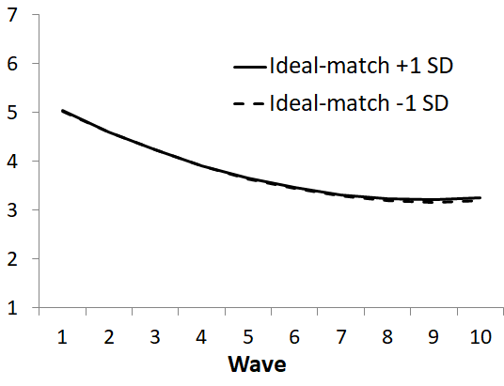

Romantic Interest

Romantic Interest

Regression term |  | B | t
Intercept β₀ |  | 5.03 | 77.22***
Time β₂ |  | -0.46 | -26.29***
Time² β₃ |  | 0.03 | 14.07***
Pattern metric β₁ |  | 0.00 | 0.08
Pattern metric × Time β₄ |  | -0.00 | -0.16
Pattern metric × Time² β₅ |  | 0.00 | 0.32

Note: Italicized rows are the focal pattern metric tests. βs refer to terms in equation 1. N = 208; degrees of freedom for β₁ - β₅ = 6091. *p < .05; ** p < .01; *** p < .001

Table S18: Level Metric Tests of Ideal Partner Preference-Matching on the Fletcher et al. (1999) Constructs

Regression Term |  | Warmth/  Trustworthiness |  | Vitality/  Attractiveness
 |  | B | t | B | t
Intercept β₀ |  | 5.03 | 77.84*** | 5.02 | 77.12***
Ideal |  | -0.09 | -1.32 | -0.01 | -0.16
Time β₂ |  | -0.47 | -25.74*** | -0.45 | -24.93***
Ideal × Time |  | -0.01 | -0.72 | -0.05 | -2.88**
Time² β₃ |  | 0.03 | 13.51*** | 0.03 | 12.76***
Ideal × Time² |  | 0.00 | -0.24 | 0.00 | 2.02*
Trait |  | 0.20 | 4.01*** | 0.32 | 6.30***
Trait × Time |  | 0.01 | 0.61 | -0.02 | -1.12
Trait × Time² |  | 0.00 | -1.20 | 0.00 | 0.11
Ideal × Trait β₁ |  | 0.03 | 0.60 | 0.00 | 0.11
Ideal × Trait × Time β₄ |  | 0.02 | 1.41 | -0.03 | -2.16*
Ideal × Trait × Time² β₅ |  | 0.00 | -0.06 | 0.01 | 2.96**

Note: “Trait” refers to the participants’ perception of the trait in the potential partner. Italicized rows are the focal level metric tests. βs refer to terms in equation 1 (other rows are control variables). Ns range from 7062 to 7178; degrees of freedom for β₁ - β₅ range from 6014 to 6104. *p < .05; ** p < .01; *** p < .001.

Figure S6 – Ideal Partner Preference-Matching Over Time in Dating Subsample (Corrected Pattern Metric, Fletcher et al., 1999, items only)

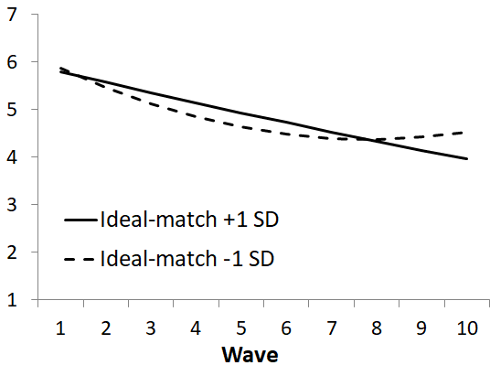

Romantic Interest

Regression term |  | B | t
Intercept β₀ |  | 5.83 | 36.69***
Time β₂ |  | -0.33 | -5.76***
Time² β₃ |  | 0.02 | 2.60**
Pattern metric β₁ |  | -0.04 | -0.22
Pattern metric × Time β₄ |  | 0.11 | 1.85
Pattern metric × Time² β₅ |  | -0.01 | -2.28*

Note: Italicized rows are the focal pattern metric tests. βs refer to terms in equation 1. N = 794; degrees of freedom for β₁ - β₅ = 678. *p < .05; ** p < .01; *** p < .001

Table S19 – Level Metric Tests of Ideal Partner Preference-Matching on the Fletcher et al. (1999) Constructs, Dating Subsample
Regression term |  | Warmth/  Trustworthiness |  | Vitality/  Attractiveness
 |  | B | t | B | t
Intercept β₀ |  | 5.81 | 35.33*** | 5.80 | 34.86***
Ideal |  | 0.06 | 0.36 | -0.06 | -0.35
Time β₂ |  | -0.37 | -6.16*** | -0.29 | -4.67***
Ideal × Time |  | -0.04 | -0.71 | -0.05 | -0.80
Time² β₃ |  | 0.02 | 3.14** | 0.01 | 1.59
Ideal × Time² |  | 0.00 | 0.39 | 0.00 | 0.59
Trait |  | 0.27 | 1.60 | 0.34 | 1.97*
Trait × Time |  | 0.03 | 0.44 | -0.05 | -0.73
Trait × Time² |  | -0.01 | -1.10 | 0.00 | 0.65
Ideal × Trait β₁ |  | 0.06 | 0.37 | 0.04 | 0.27
Ideal × Trait × Time β₄ |  | 0.14 | 2.39* | -0.08 | -1.53
Ideal × Trait × Time² β₅ |  | -0.02 | -2.64** | 0.01 | 1.73

Note: “Trait” refers to the participants’ perception of the trait in the potential partner. Bolded rows are the focal level metric tests. βs refer to terms in equation 1 (other rows are control variables). N = 794; degrees of freedom for β₁ - β₅ = 678. *p < .05; ** p < .01; *** p < .001.

Coder-rated Physical Attractiveness
At the very end of the entire study, participants had the opportunity to upload photographs of the potential partners they had nominated over the course of the study. The instructions read:
Please select photographs (from Facebook or any other source) that most accurately represent what these people look like. Also, please ensure that they are the only person in the photograph either by selecting photos in which they are the only person featured, or by cropping other individuals out of the photo before uploading it so that we can correctly identify them.
Of the 1,065 potential partners, participants uploaded photographs for N = 839 (79%) of them. Seven research assistants rated the photographs one-at-a-time on “physical attractiveness” using a 1-10 rating scale; α = .92, M = 5.7, SD = 1.6.
We standardized this variable and used it as a predictor in equation 1. Results are depicted in Figure S7. Coder-rated physical attractiveness did not have a significant effect on romantic interest. If we simply eliminate all the terms involving Time and Time² from the analysis, the overall effect of coder-rated attractiveness (i.e., at the average time point in the sample) is β = .03, t (4973) = -0.38, p = .243.
This analysis suggests that the current context (i.e., early relationship development) is more akin to a close relationships context (in which the effect of coder-rated attractiveness is also very small: r = ~.05; Eastwick et al., 2014) rather than an initial attraction context (in which the effect of coder-rated attractiveness is quite large: r = ~.50 (Back et al., 2011).
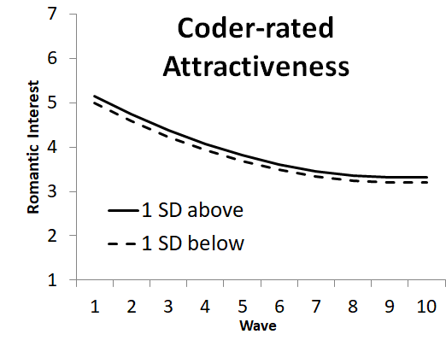
Figure S7 – Coder-rated Attractiveness of Potential Partners as a Predictor in Equation 1
Table S20 – Individual-Difference Report Variables: Descriptive Statistics
Construct |  | Mean | SD | N
Age |  | 18.11 | 0.31 | 208
Agreeableness |  | 7.00 | 1.30 | 208
Approach goals |  | 5.57 | 0.97 | 195
Assessment |  | 4.88 | 0.80 | 208
Attachment anxiety |  | 3.82 | 1.09 | 206
Attachment avoidance |  | 3.39 | 1.08 | 200
Attractive resistance |  | 4.27 | 1.82 | 207
Avoidance goals |  | 5.31 | 0.95 | 195
Behavioral activation (drive) |  | 4.55 | 1.10 | 208
Behavioral activation (fun) |  | 5.13 | 0.98 | 208
Behavioral activation (reward) |  | 5.90 | 0.65 | 208
Behavioral inhibition |  | 2.88 | 0.98 | 208
Capitalization |  | 5.19 | 1.19 | 207
Casual sex disapproval (family) |  | 5.37 | 1.80 | 208
Casual sex disapproval (friends) |  | 3.65 | 1.87 | 208
Cheating |  | 2.32 | 1.71 | 207
Collective self-construal |  | 5.03 | 1.28 | 208
Conscientiousness |  | 5.53 | 1.54 | 208
Control over passion |  | 4.20 | 1.23 | 208
Depression |  | 0.63 | 0.43 | 208
Desperation |  | 3.06 | 1.47 | 208
Destiny beliefs |  | 3.53 | 0.91 | 208
Education (father) |  | 5.20 | 1.25 | 203
Education (mother) |  | 4.95 | 1.25 | 206
Extraversion |  | 5.55 | 1.76 | 208
Forgiveness |  | 4.38 | 1.35 | 208
Friend value |  | 5.59 | 0.87 | 208
Friendship comfort |  | 5.16 | 1.33 | 208
Friendship initiation |  | 4.39 | 1.44 | 208
Friendship standards |  | 4.35 | 1.51 | 208
Gender |  | 1.56 | 0.50 | 208
Gender identity |  | 4.61 | 1.60 | 208
Growth beliefs |  | 5.03 | 0.65 | 208
Health (overall) |  | 3.79 | 0.83 | 208
Health (symptoms) |  | 1.25 | 0.15 | 208
Height |  | 67.83 | 3.82 | 208
Ideal friend: ambitious |  | 5.08 | 1.24 | 208
Ideal friend: attractive |  | 4.28 | 1.35 | 208
Ideal friend: confident |  | 5.29 | 1.07 | 208
Ideal friend: creative |  | 4.70 | 1.36 | 208
Ideal friend: dependable |  | 6.12 | 0.91 | 208
Ideal friend: dominant |  | 3.66 | 1.15 | 208
Ideal friend: exciting |  | 5.69 | 0.97 | 208
Ideal friend: level-headed |  | 5.22 | 1.08 | 207
Ideal friend: optimistic |  | 5.26 | 1.16 | 208
Ideal friend: passive |  | 3.49 | 1.26 | 206
Ideal friend: Patient |  | 5.00 | 1.22 | 208
Ideal friend: realistic |  | 4.85 | 1.29 | 208
Ideal friend: spontaneous |  | 5.01 | 1.30 | 208
Ideal friend: supportive |  | 6.04 | 0.89 | 208
Ideal partner: ambitious |  | 5.55 | 1.15 | 208
Ideal partner: attractive |  | 6.03 | 0.81 | 208
Ideal partner: confident |  | 5.69 | 0.93 | 208
Ideal partner: creative |  | 4.88 | 1.29 | 208
Ideal partner: dependable |  | 6.29 | 0.75 | 208
Ideal partner: dominant |  | 4.10 | 1.40 | 208
Ideal partner: exciting |  | 5.83 | 0.91 | 208
Ideal partner: level-headed |  | 5.59 | 1.03 | 207
Ideal partner: optimistic |  | 5.51 | 0.96 | 208
Ideal partner: passive |  | 3.33 | 1.30 | 208
Ideal partner: patient |  | 5.56 | 1.05 | 208
Ideal partner: realistic |  | 5.36 | 1.10 | 207
Ideal partner: spontaneous |  | 5.31 | 1.12 | 208
Ideal partner: supportive |  | 6.29 | 0.78 | 208
Impression management |  | 4.00 | 0.80 | 208
Income (household) |  | 4.16 | 1.96 | 186
Independence |  | 4.82 | 0.70 | 208
Interdependence |  | 4.97 | 0.64 | 208
Liberal |  | 5.05 | 1.47 | 204
Limerence |  | 4.85 | 1.16 | 208
Locomotion |  | 4.90 | 0.74 | 208
Loneliness |  | 2.91 | 1.58 | 208
Long-term preference |  | 5.34 | 1.50 | 207
Mate value |  | 4.12 | 1.27 | 207
Naps |  | 2.43 | 0.95 | 208
Narcissism |  | 4.31 | 0.85 | 208
Need to belong |  | 4.82 | 0.79 | 208
Neuroticism |  | 4.36 | 1.67 | 208
Openness |  | 6.46 | 1.43 | 208
Parental divorce |  | 1.82 | 0.38 | 208
Passion theories |  | 3.07 | 0.75 | 207
PDA |  | 3.83 | 1.27 | 207
Power |  | 4.35 | 0.68 | 207
Prevention focus |  | 4.54 | 1.28 | 208
Promotion focus |  | 5.51 | 0.82 | 208
Reciprocity (friend) |  | 5.64 | 0.86 | 208
Reciprocity (romantic) |  | 4.89 | 0.81 | 208
Rejection sensitivity (concern) |  | 3.63 | 0.90 | 208
Rejection sensitivity (expectations) |  | 4.58 | 0.64 | 208
Relational self-construal |  | 5.25 | 1.34 | 208
Romantic comfort |  | 3.73 | 1.71 | 207
Romantic initiation |  | 3.50 | 1.57 | 203
Romantic standards |  | 5.40 | 1.29 | 206
R'ship goals: casual dates |  | 0.65 | 0.48 | 208
R'ship goals: casual friend |  | 0.86 | 0.35 | 208
R'ship goals: close friend |  | 0.97 | 0.18 | 208
R'ship goals: serious |  | 0.41 | 0.49 | 208
R'ship goals: short-term |  | 0.34 | 0.48 | 208
R'ships long-term |  | 4.71 | 1.65 | 206
R'ships serious |  | 3.89 | 1.76 | 188
Self-concept clarity |  | 3.94 | 1.15 | 208
Self-esteem |  | 5.34 | 1.08 | 208
Self: ambitious |  | 5.79 | 1.07 | 208
Self: attractive |  | 4.94 | 1.22 | 208
Self: confident |  | 5.06 | 1.50 | 208
Self: creative |  | 4.94 | 1.46 | 208
Self: dependable |  | 5.93 | 0.94 | 208
Self: dominant |  | 4.02 | 1.42 | 208
Self: exciting |  | 5.03 | 1.25 | 208
Self: level-headed |  | 5.49 | 1.17 | 207
Self: optimistic |  | 5.24 | 1.45 | 208
Self: passive |  | 3.95 | 1.60 | 207
Self: patient |  | 4.42 | 1.56 | 208
Self: realistic |  | 5.66 | 1.20 | 208
Self: spontaneous |  | 4.81 | 1.49 | 208
Self: supportive |  | 5.92 | 1.09 | 208
Self-control |  | 3.83 | 0.84 | 208
Self-respect |  | 5.61 | 1.00 | 208
Sex drive |  | 4.49 | 1.50 | 206
Sexual orientation |  | 6.39 | 1.04 | 208
Sleep quality |  | 3.18 | 0.73 | 208
Social anxiety |  | 3.50 | 1.15 | 208
Social desirability |  | 3.38 | 0.74 | 208
Sociosexuality (attitudes) |  | 4.08 | 0.85 | 207
Sociosexuality (behaviors) |  | 0.00 | 0.88 | 208
Sociosexuality (desire) |  | 4.51 | 2.10 | 205
Staying awake |  | 1.94 | 0.89 | 208
Stereotype awareness (general) |  | 3.64 | 1.71 | 135
Stereotype awareness (specific) |  | 2.34 | 1.33 | 133
Stereotype endorsement |  | 1.76 | 1.12 | 135
Subjective well-being |  | 5.34 | 1.09 | 208
Values: achievement |  | 7.80 | 1.23 | 208
Values: authority |  | 5.96 | 1.92 | 208
Values: avoid hurting partners |  | 5.25 | 1.26 | 194
Values: benevolence |  | 6.99 | 1.54 | 208
Values: casual sex |  | 3.92 | 2.14 | 208
Values: compassion |  | 7.60 | 1.52 | 208
Values: conformity |  | 5.66 | 1.87 | 207
Values: fairness |  | 7.39 | 1.41 | 208
Values: hedonism |  | 7.02 | 1.43 | 208
Values: love |  | 8.04 | 1.25 | 207
Values: power |  | 6.27 | 1.83 | 208
Values: purity |  | 4.35 | 2.25 | 203
Values: relationships |  | 8.30 | 1.01 | 208
Values: religion |  | 4.33 | 2.66 | 207
Values: security |  | 7.46 | 1.58 | 208
Values: self-direction |  | 7.25 | 1.48 | 208
Values: stimulation |  | 6.86 | 1.35 | 208
Values: tradition |  | 4.92 | 2.03 | 207
Values: universalism |  | 7.15 | 1.63 | 208
Values: wealth |  | 6.04 | 1.89 | 208
Variety preference |  | 3.01 | 1.76 | 206
Weight |  | 144.06 | 27.86 | 208
Well being (autonomy) |  | 4.90 | 0.99 | 208
Well being (growth) |  | 5.81 | 0.73 | 208
Well being (mastery) |  | 4.95 | 1.02 | 208
Well being (purpose) |  | 5.55 | 0.93 | 208
Well being (relationships) |  | 5.10 | 1.23 | 208
Well being (self-acceptance) |  | 5.48 | 1.13 | 208

Note: For more details, visit our osf page, click on Materials, then NRIS_Codebook.xlsx (for items and scales) and CorrelationTables.xlsx (for correlations among these items). Means calculated across all N = 208 participants.

Table S21 – Target-Specific Variables: Descriptive Statistics
Construct |  | Mean | SD | N
Desirable alternatives |  | 4.47 | 1.47 | 970
Investments |  | 3.33 | 1.68 | 1051
Mixed signals |  | 3.80 | 1.62 | 1038
Partner r’ship status |  | 2.29 | 0.61 | 1065
Partner: ambitious |  | 5.56 | 1.04 | 1034
Partner: attractive |  | 5.90 | 0.90 | 1065
Partner: confident |  | 5.71 | 0.97 | 1047
Partner: creative |  | 5.20 | 1.12 | 1019
Partner: dependable |  | 5.28 | 1.16 | 1026
Partner: dominant |  | 4.48 | 1.32 | 1033
Partner: exciting |  | 5.47 | 1.01 | 1045
Partner: level-headed |  | 5.31 | 1.13 | 1026
Partner: optimistic |  | 5.31 | 1.08 | 1032
Partner: passive |  | 3.69 | 1.38 | 1033
Partner: patient |  | 5.11 | 1.17 | 1028
Partner: realistic |  | 5.31 | 1.04 | 1028
Partner: spontaneous |  | 5.08 | 1.19 | 1034
Partner: supportive |  | 5.33 | 1.08 | 1020
Partner-disclosure |  | 4.02 | 1.53 | 1031
Perceived interest |  | 4.06 | 1.50 | 1045
Prevention facilitation |  | 3.80 | 1.50 | 1028
Promotion facilitation |  | 3.94 | 1.49 | 1029
Proximity seeking |  | 4.05 | 1.62 | 1051
Relative power |  | 3.80 | 1.08 | 947
Safe haven |  | 2.82 | 1.44 | 1045
Secure base |  | 3.04 | 1.51 | 1045
Self-disclosure |  | 4.26 | 1.57 | 1042
Separation distress |  | 3.08 | 1.52 | 1048
Sexual contact |  | 1.80 | 0.40 | 1059
Trust |  | 4.75 | 1.39 | 1037

Note: For more details, visit our osf page, click on Materials, then NRIS_Codebook.xlsx (for items and scales) and CorrelationTables.xlsx (for correlations among these items). Means calculated across all N = 1,065 Time 1 target-specific reports.

